Question : Install ansible and connect the nodes to master and execute the adhoc commands on ansible masternode vm and test the packages installed or not.

On aws console create 3 machine one is master and 2 machines are node.

**On Master :**

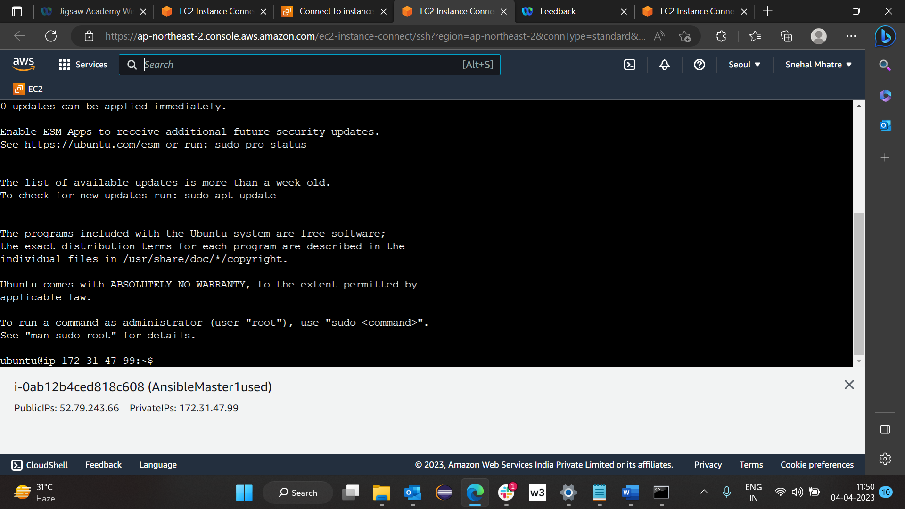

Step 1 : type on master >> sudo apt update

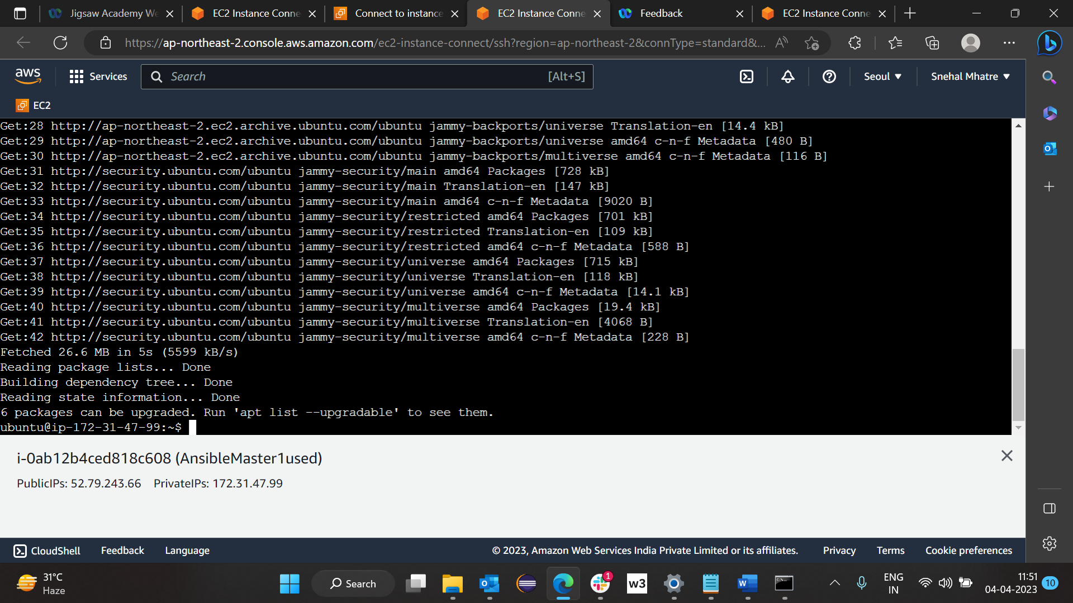

Step 2: On master >> sudo apt install software-properties-common

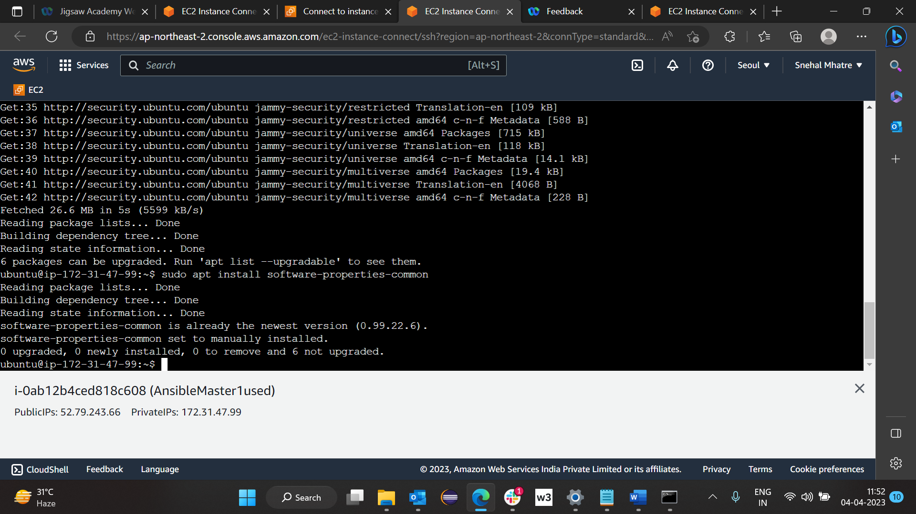

Step 3: On master >> sudo add-apt-repository --yes --update ppa:ansible/ansible

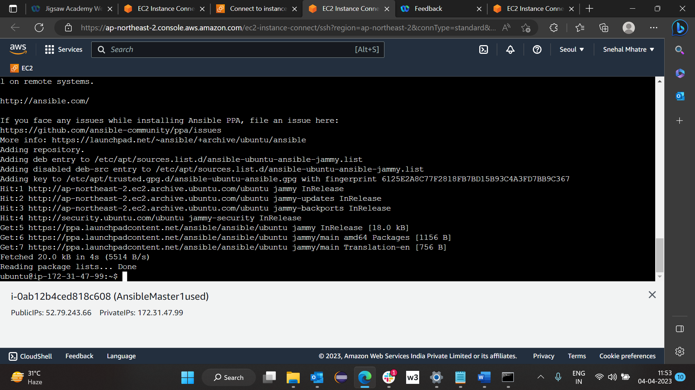

Step4: On Master >> sudo apt install ansible

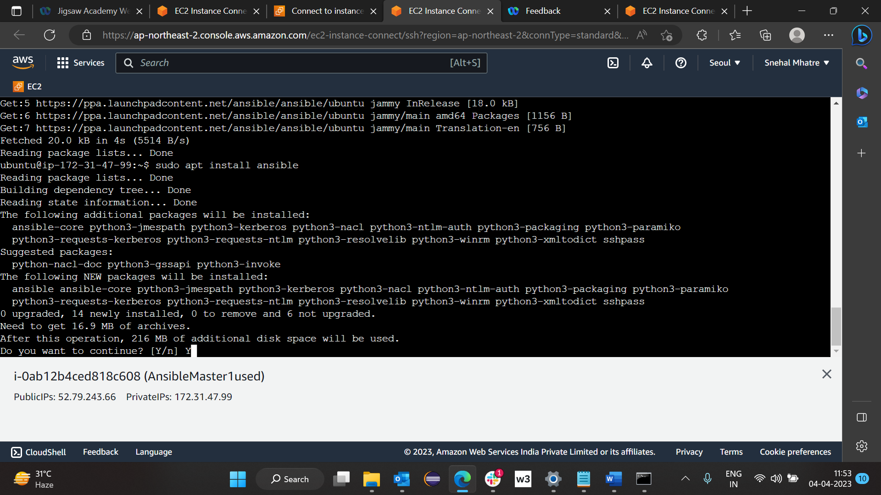

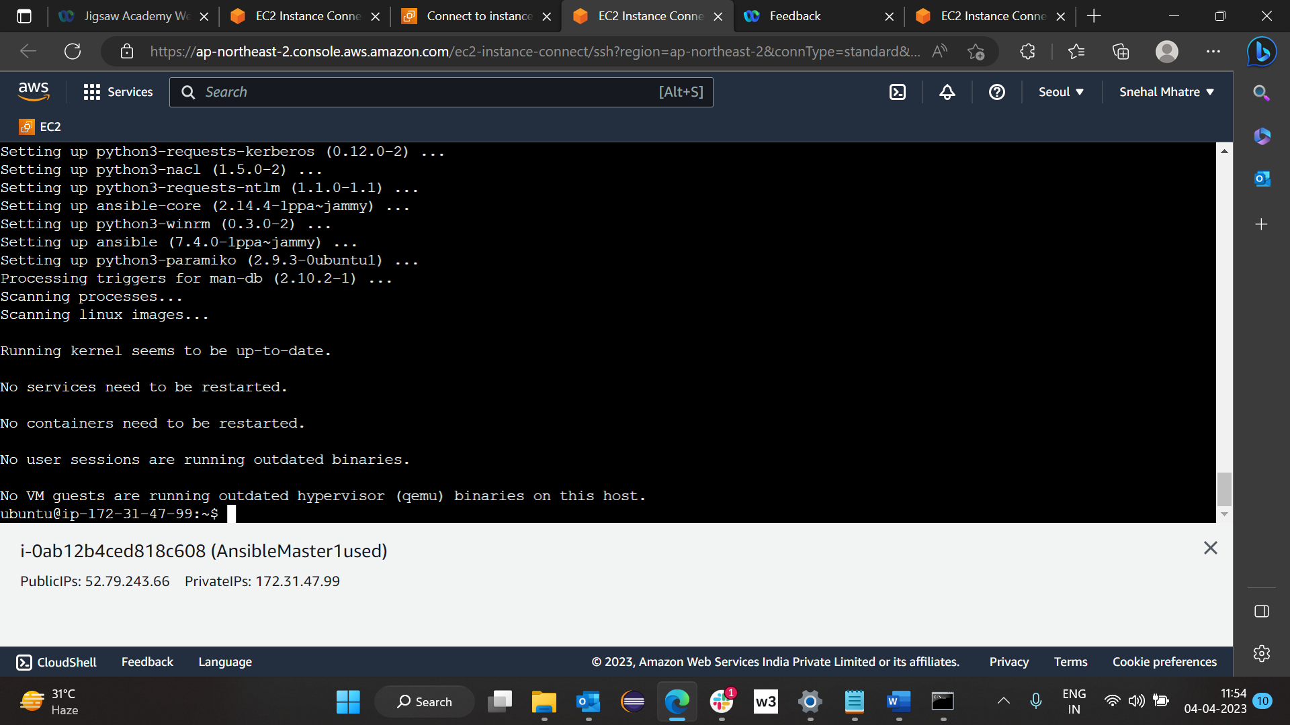

After installing ansible : on master>> ansible --version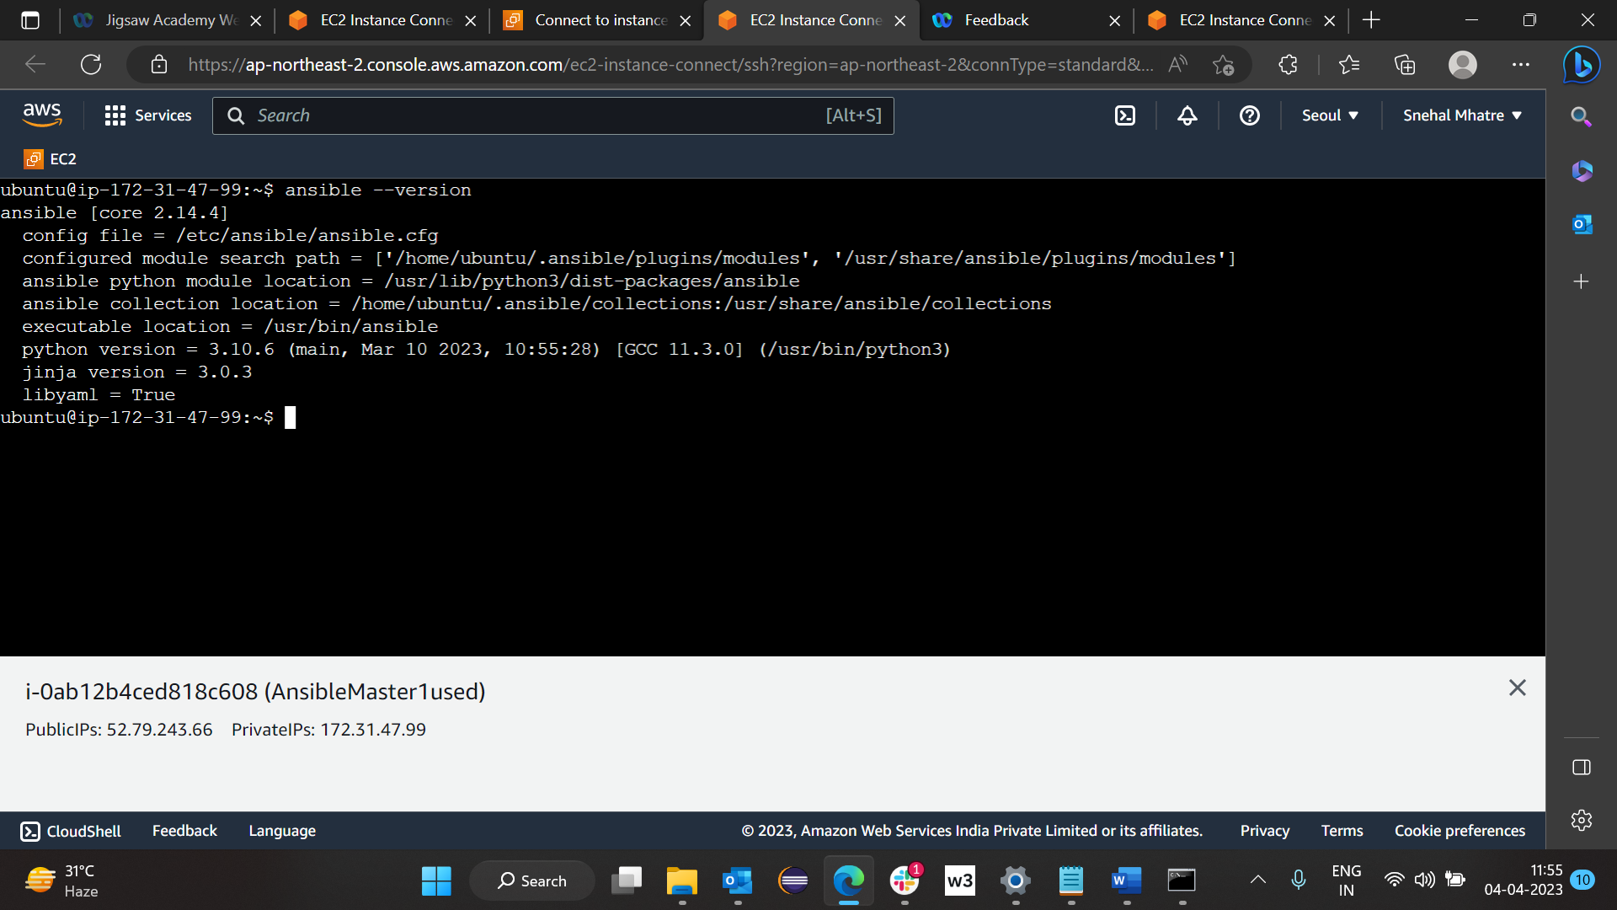

To show all hidden files. Type on master >> ls -a

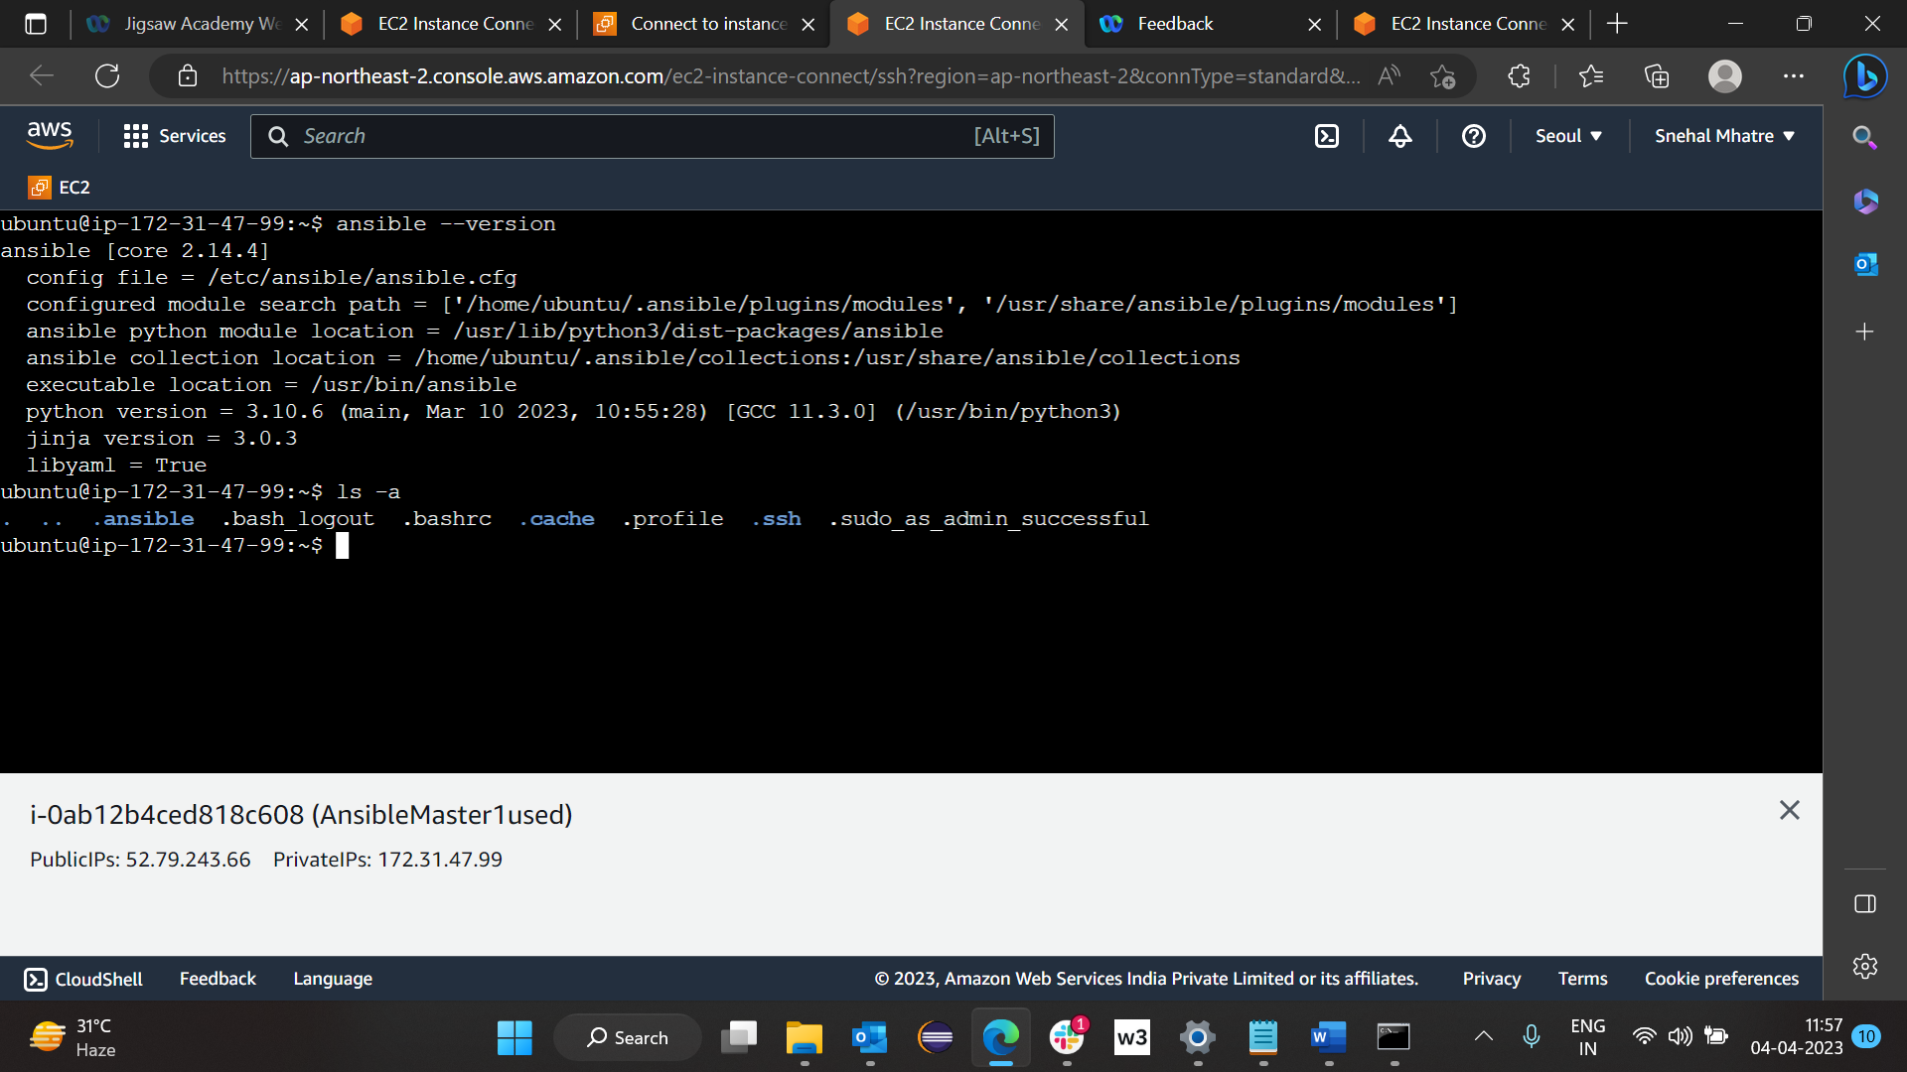

Go to folder .ssh which is hidden folder. Type on Master >> cd .ssh

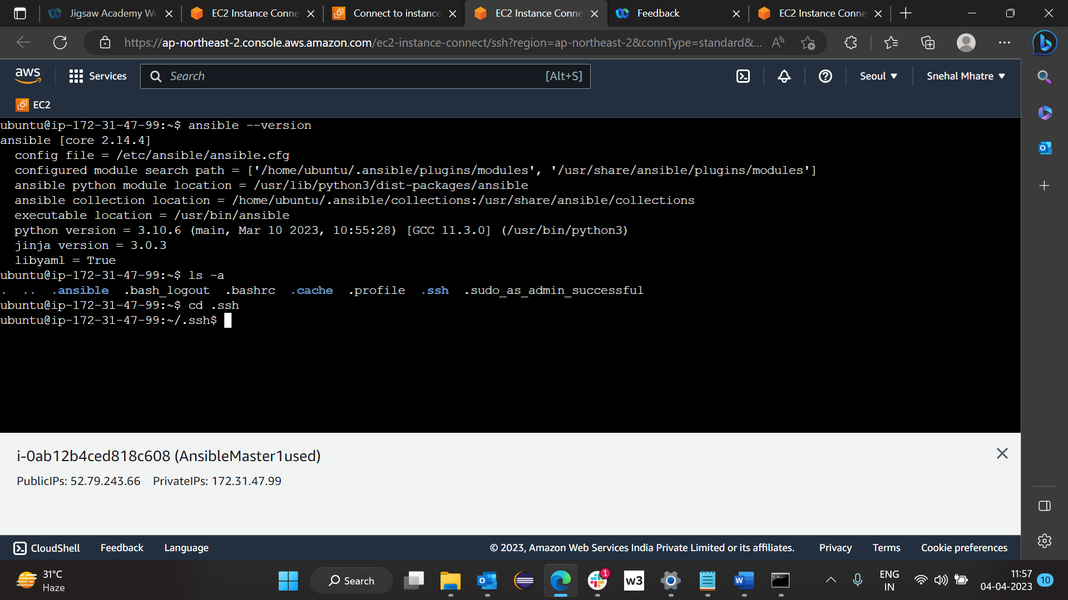

On Master when in .ssh folder type >> ls

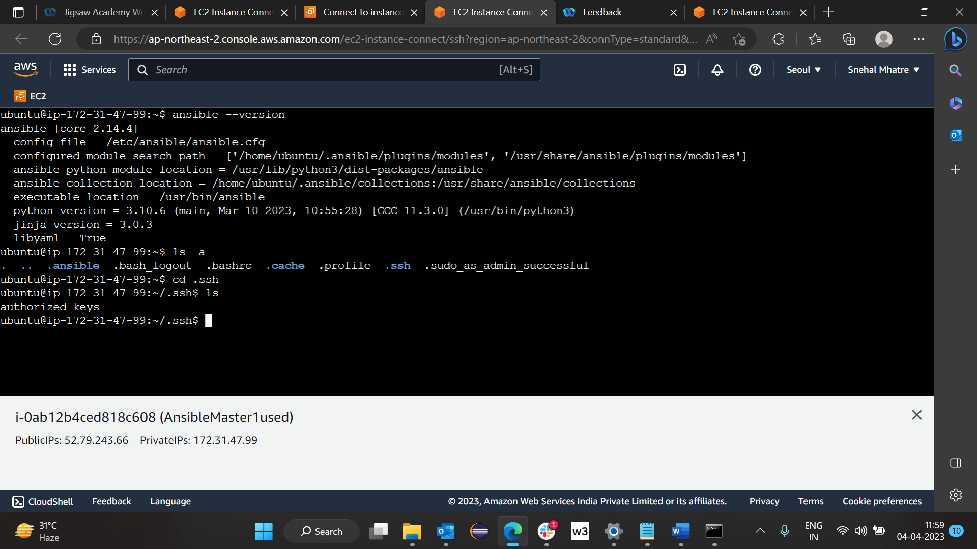

To generate key in .ssh folder type on master >> ssh-keygen

Here press enter for 3 times

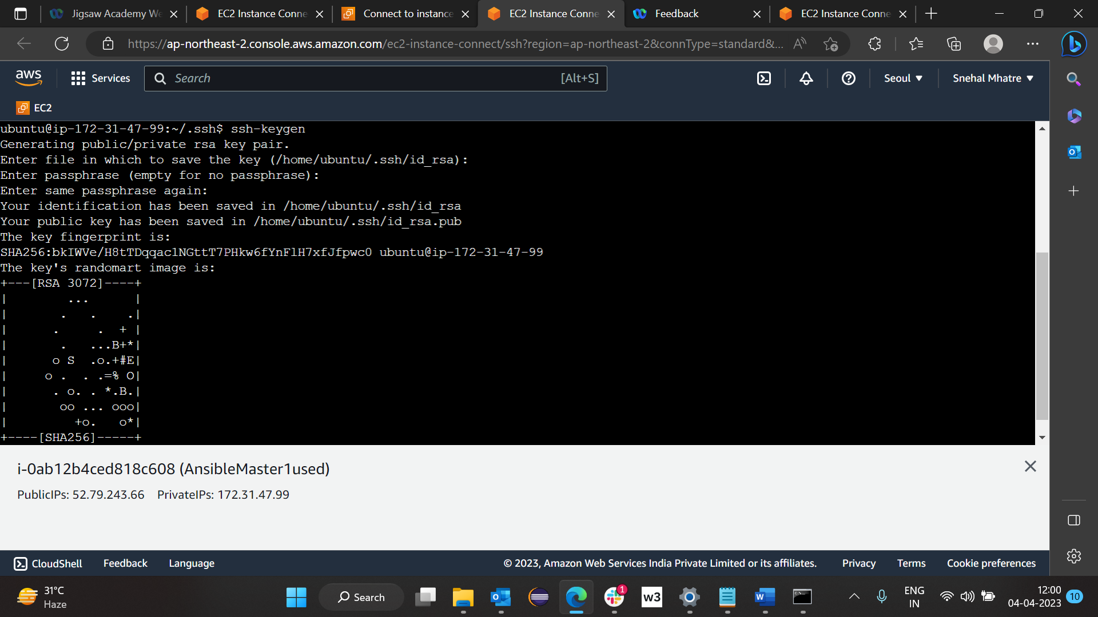

Again on master >> ls

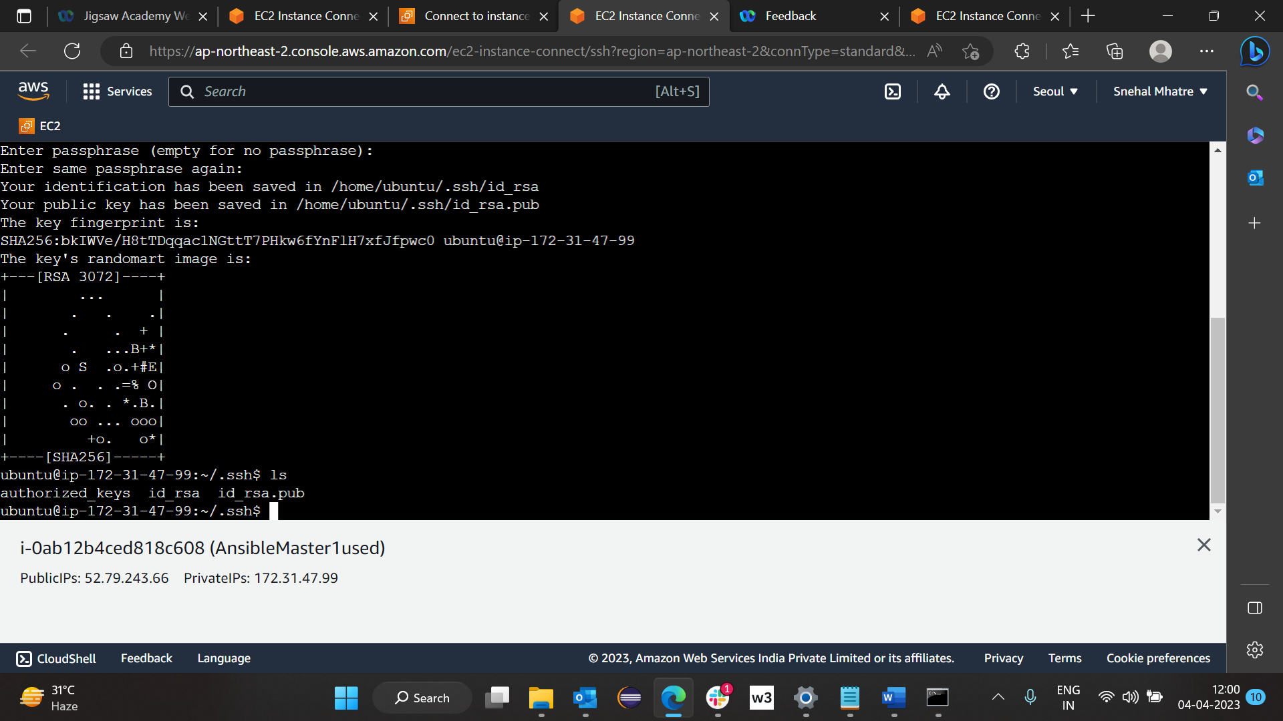

On master to check data of file id_rsa.pub press >> cat id_rsa.pub

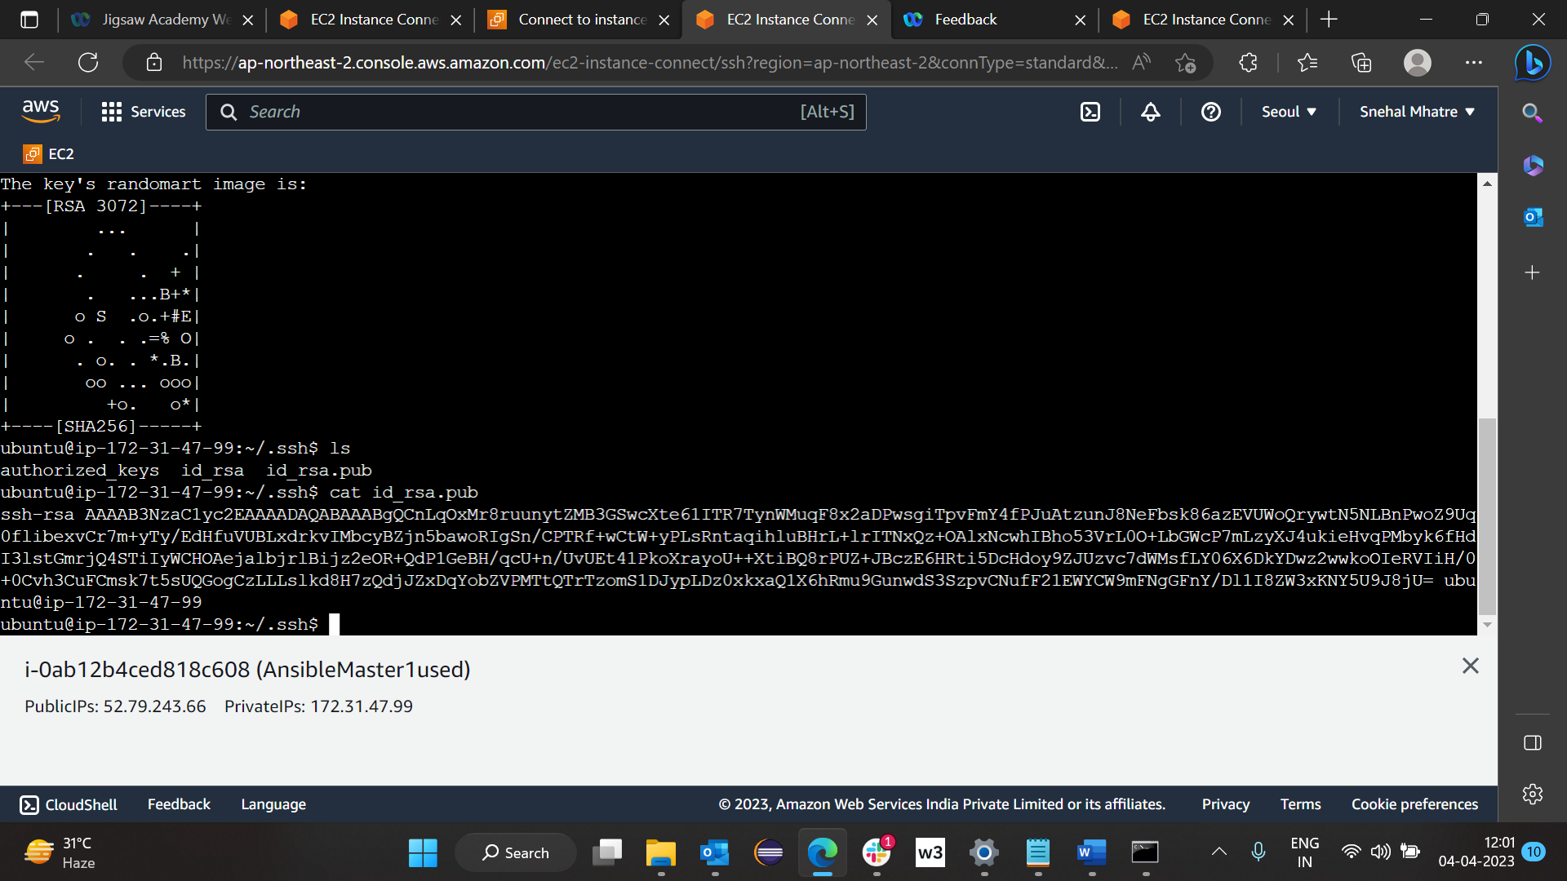

Copy above key on notepad:

ssh-rsa  ubuntu@ip-172-31-47-99

After above steps completed go to node1 and node2 set up (search for **Node Set UP:**) perform all steps mentioned in node setup and again come back here and perform following steps.

Now on master type >> cd ../../..

>> cd etc

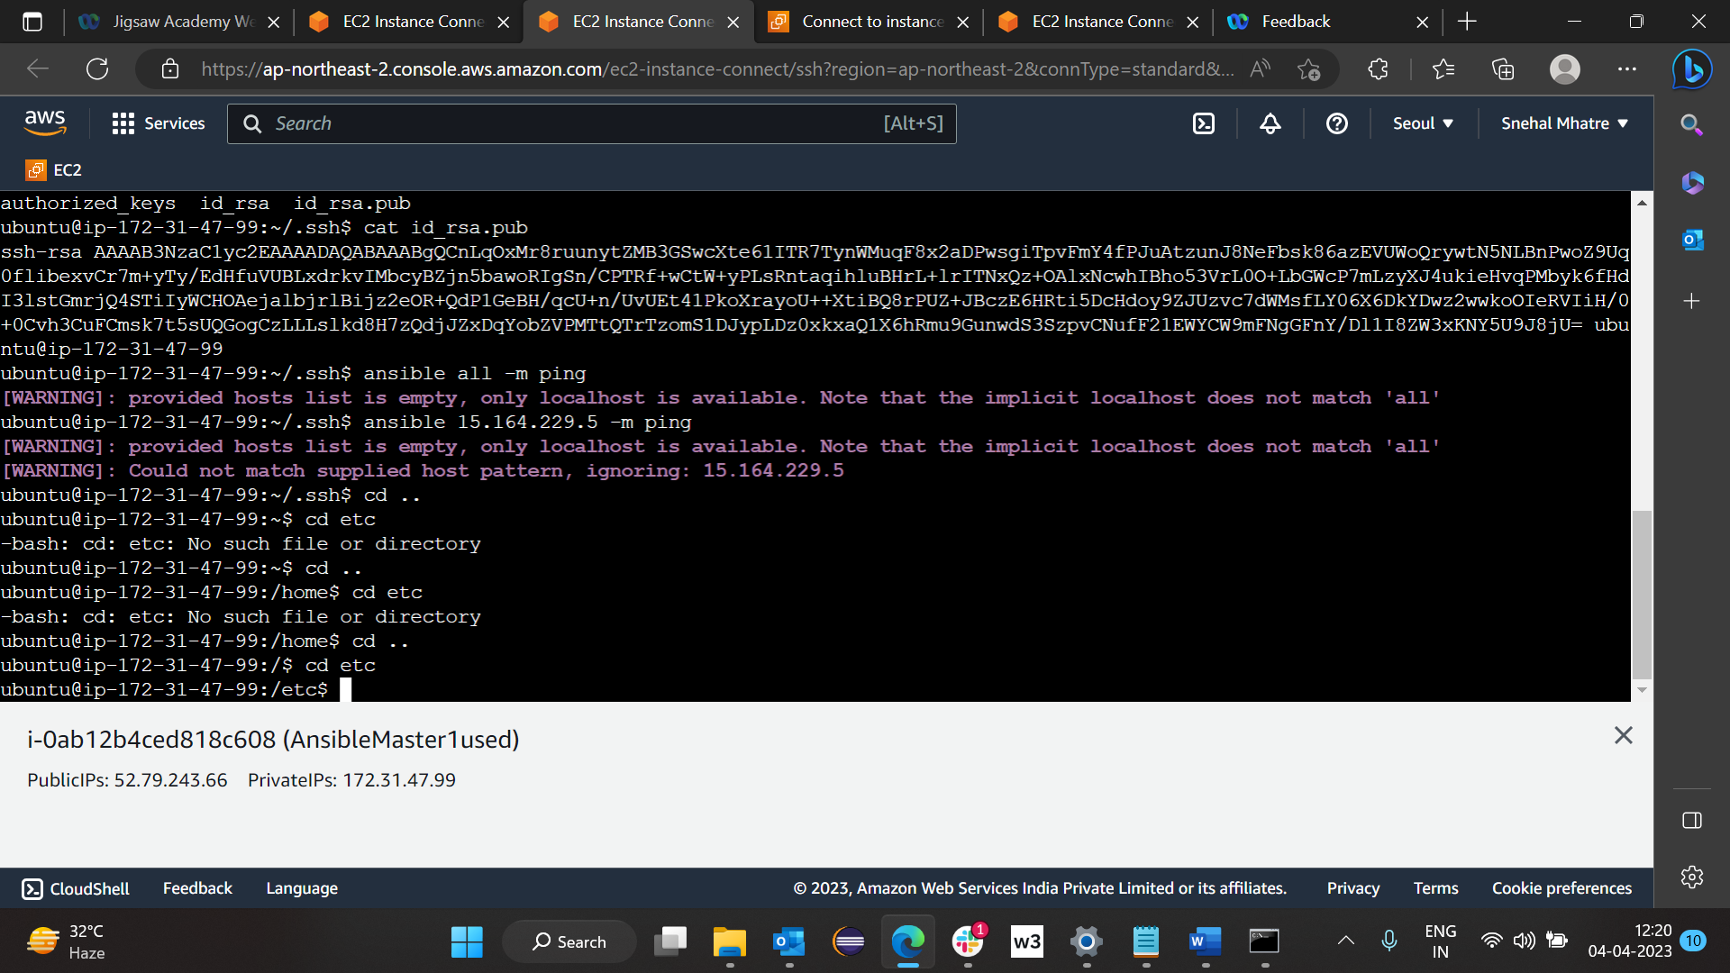

Type >> cd ansible

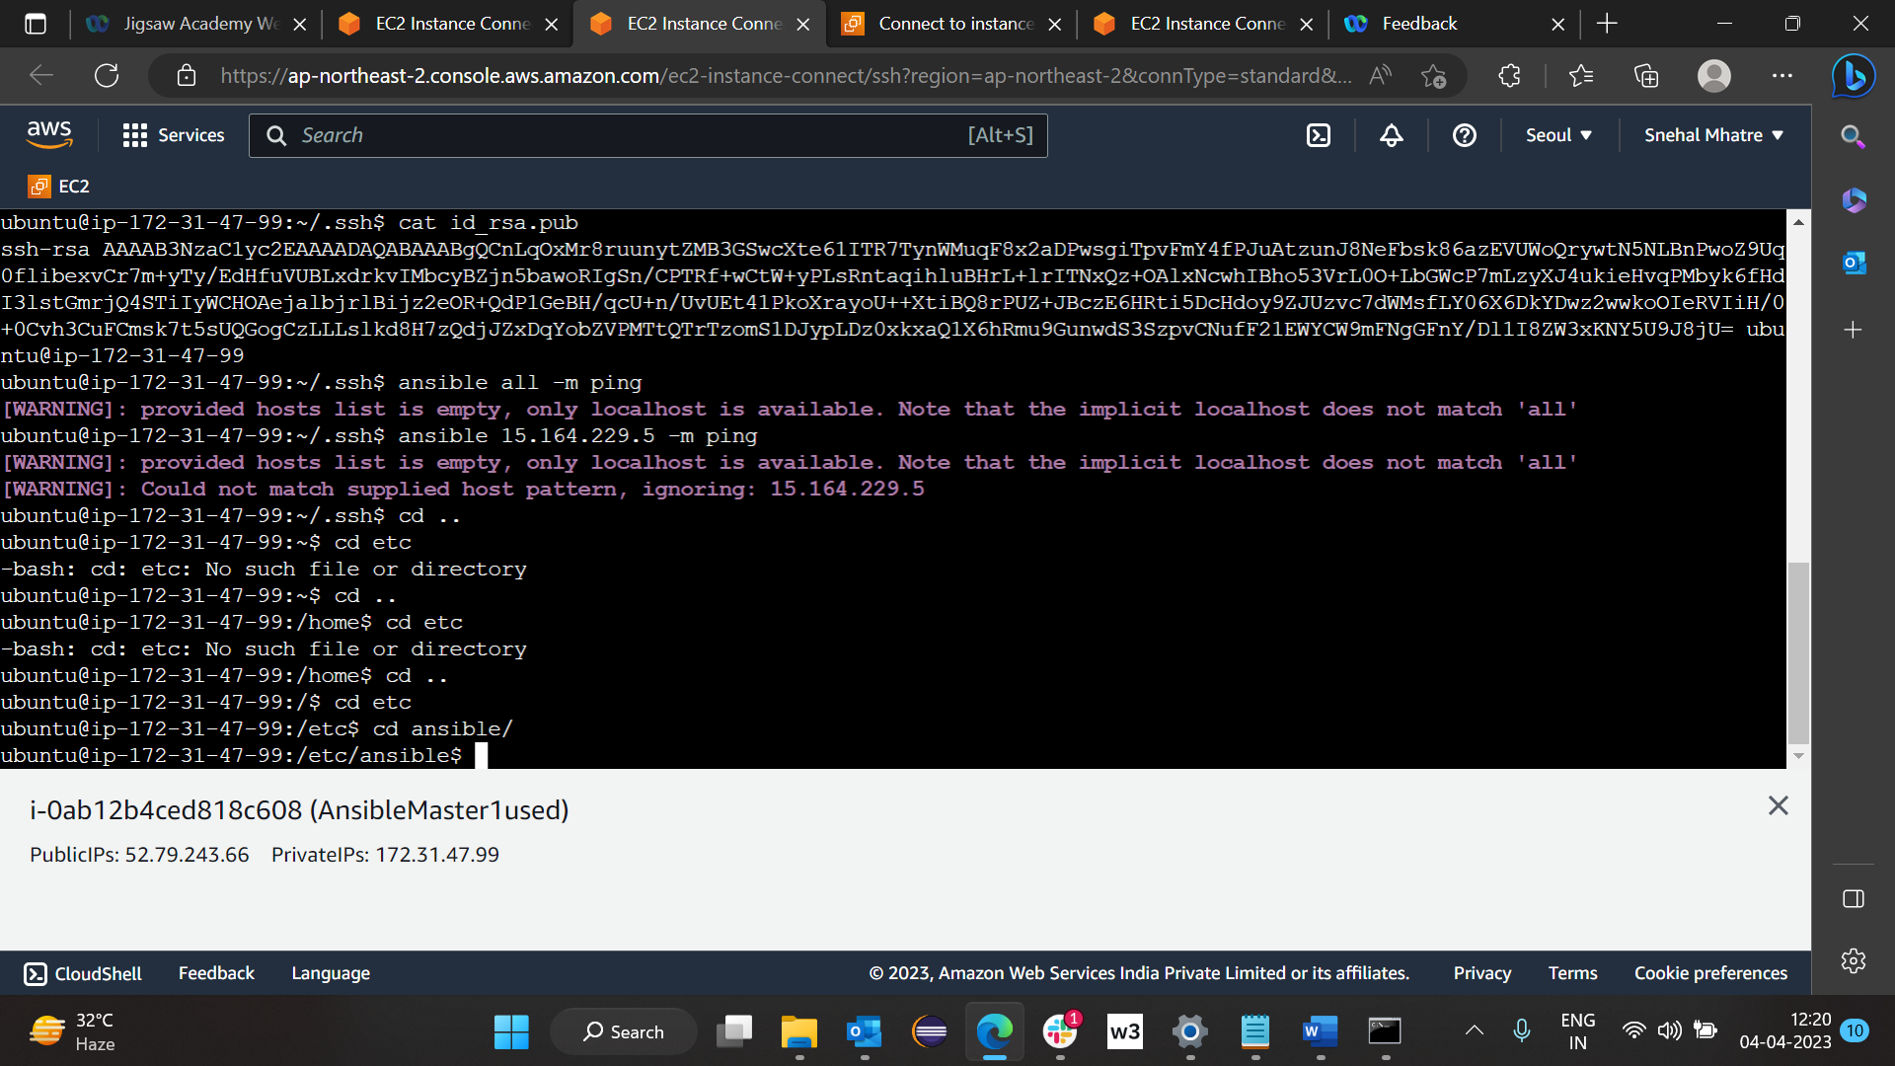

Give permission to host file >> sudo chmod 777 hosts

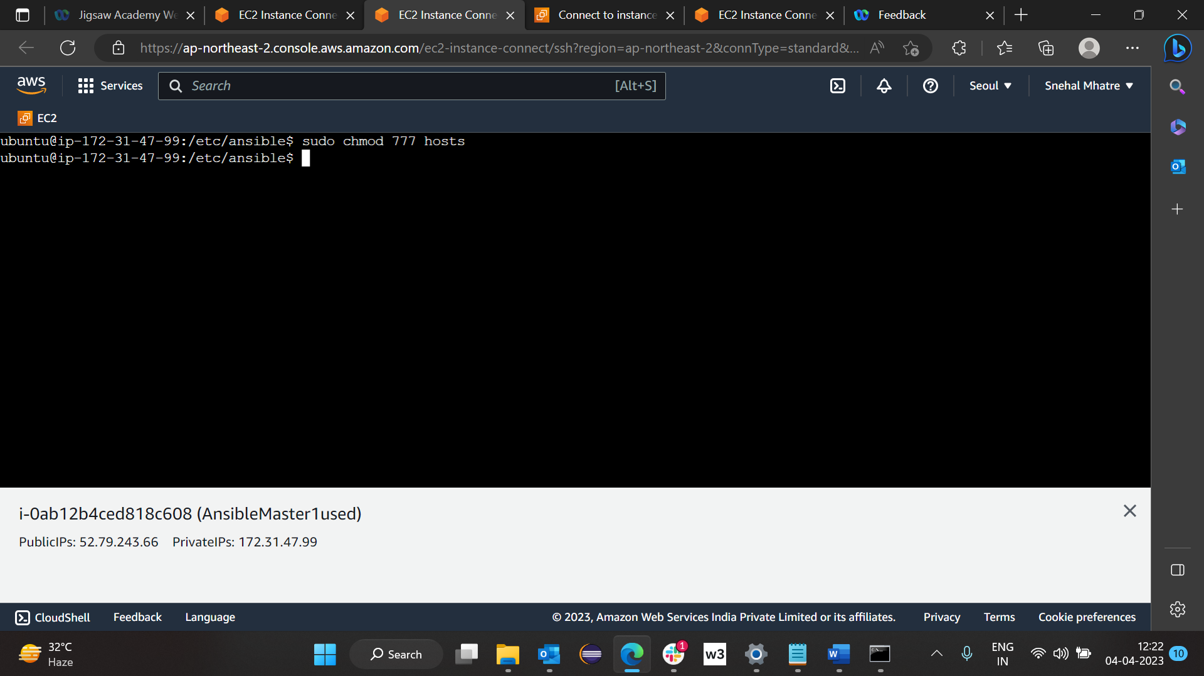

Now open hosts file >> vi hosts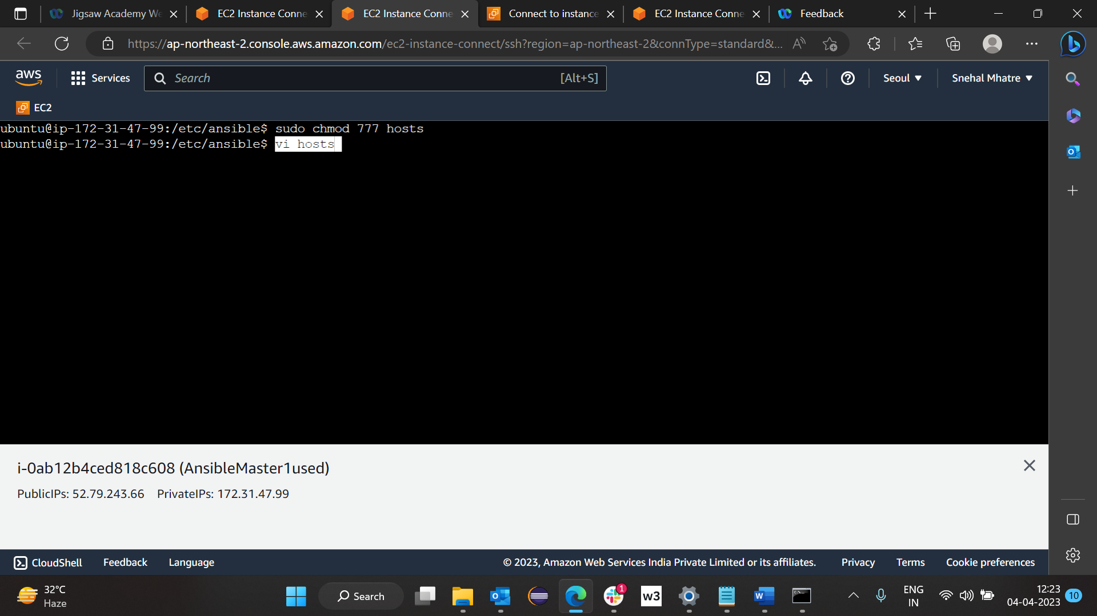

Come at end of hosts file and type

>> [ibmserverlist]

Ip address of nonde 1

Ip address of node2

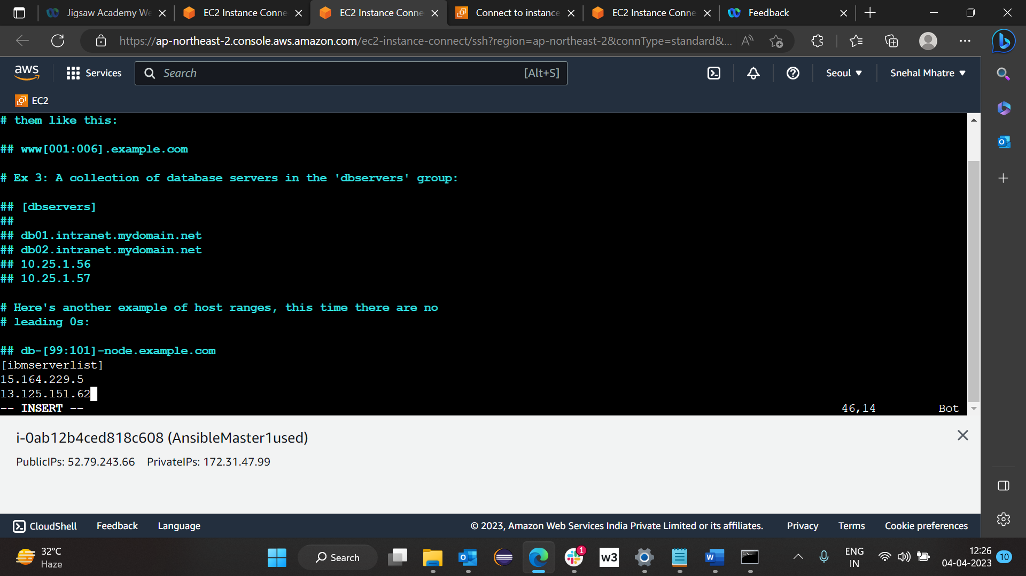

Now save file by pressing esc and :wq!

Now on master >> type >> ansible ipaddress node 1

Eg >> ansible 13.125.151.62 -m ping

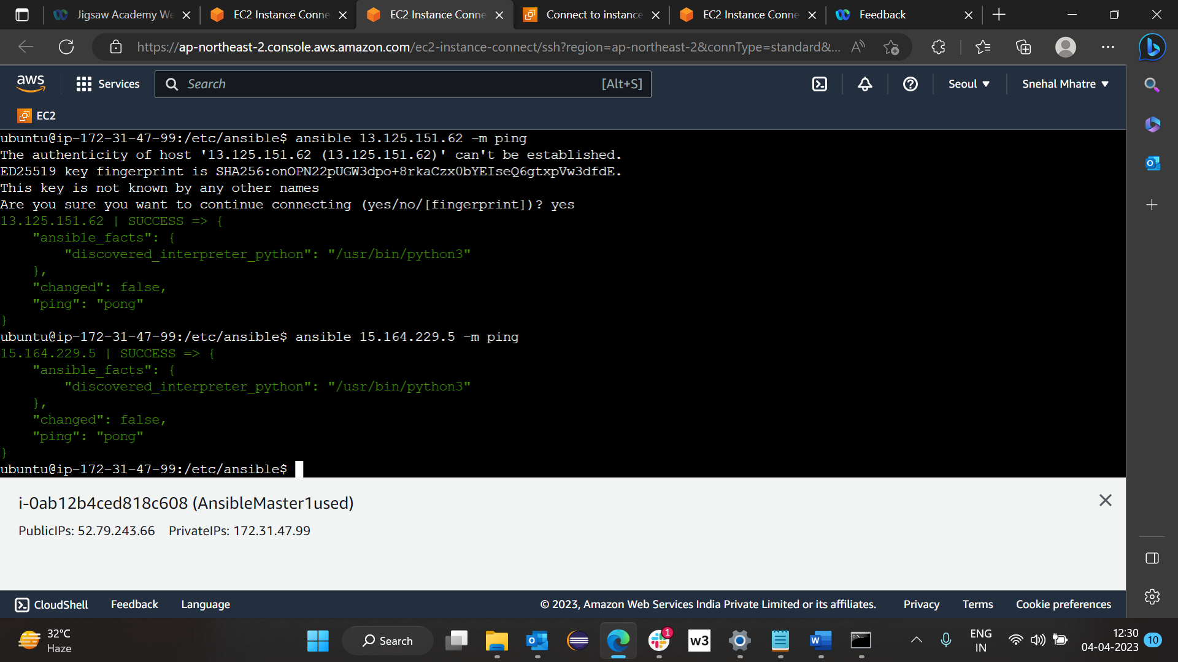

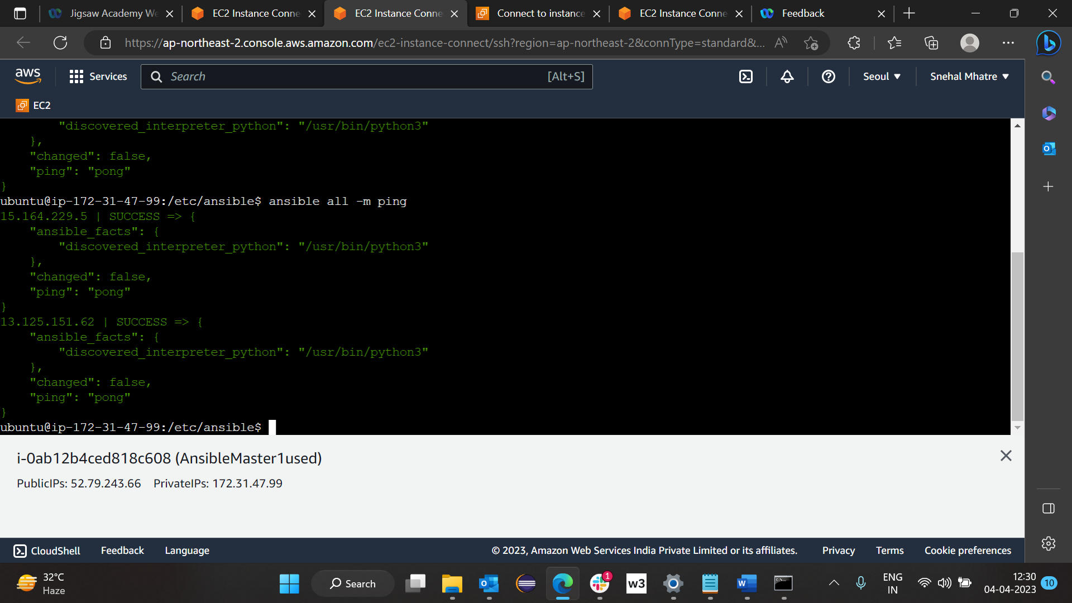

Updating node machines >> ansible all -b -a "apt update"

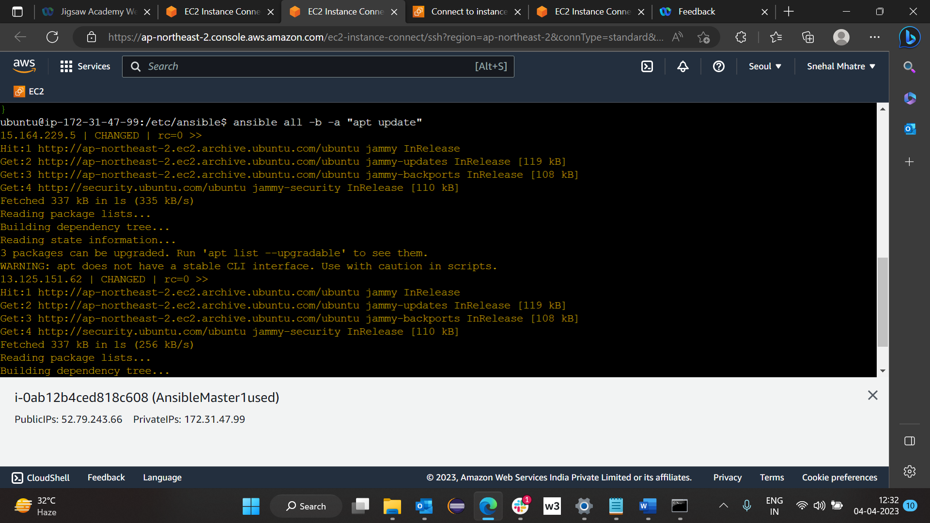

To remove git which are already install on node >> ansible all -b -a "apt remove git -y"

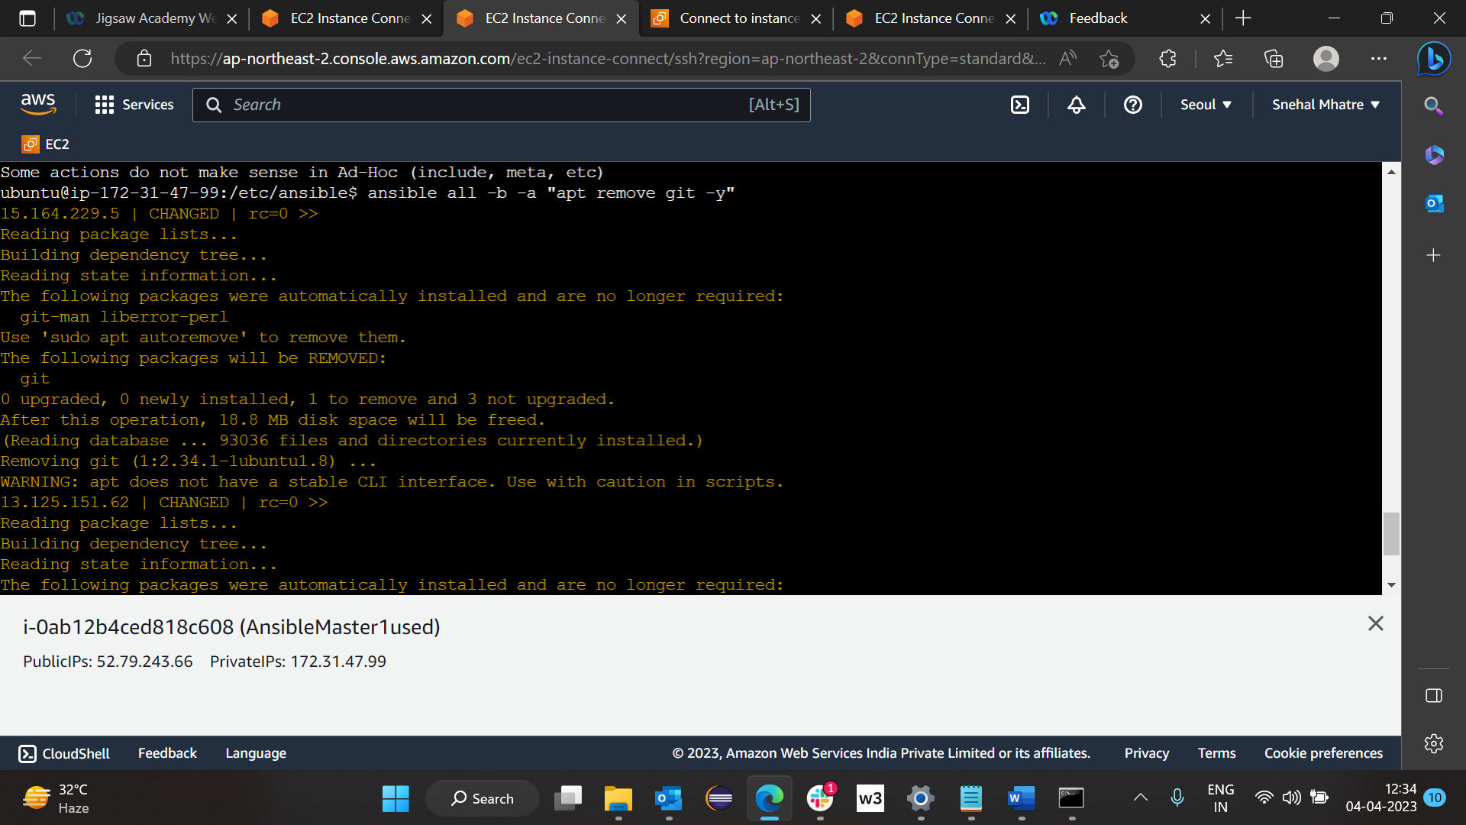

Now if we check node1 : >> git version

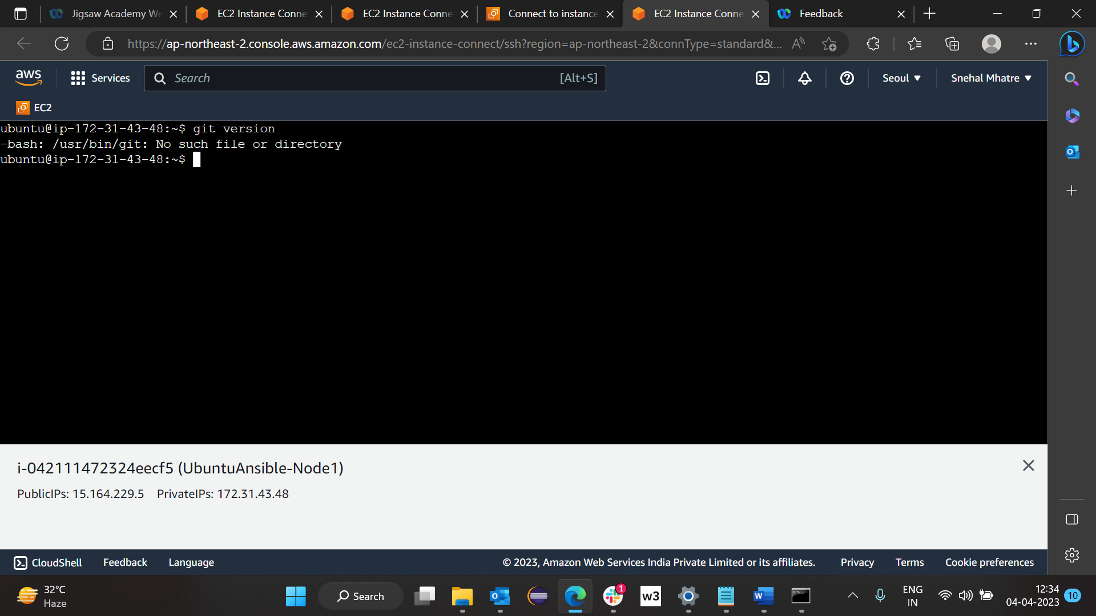

Same for node2 earlier is showing git version but after removing git

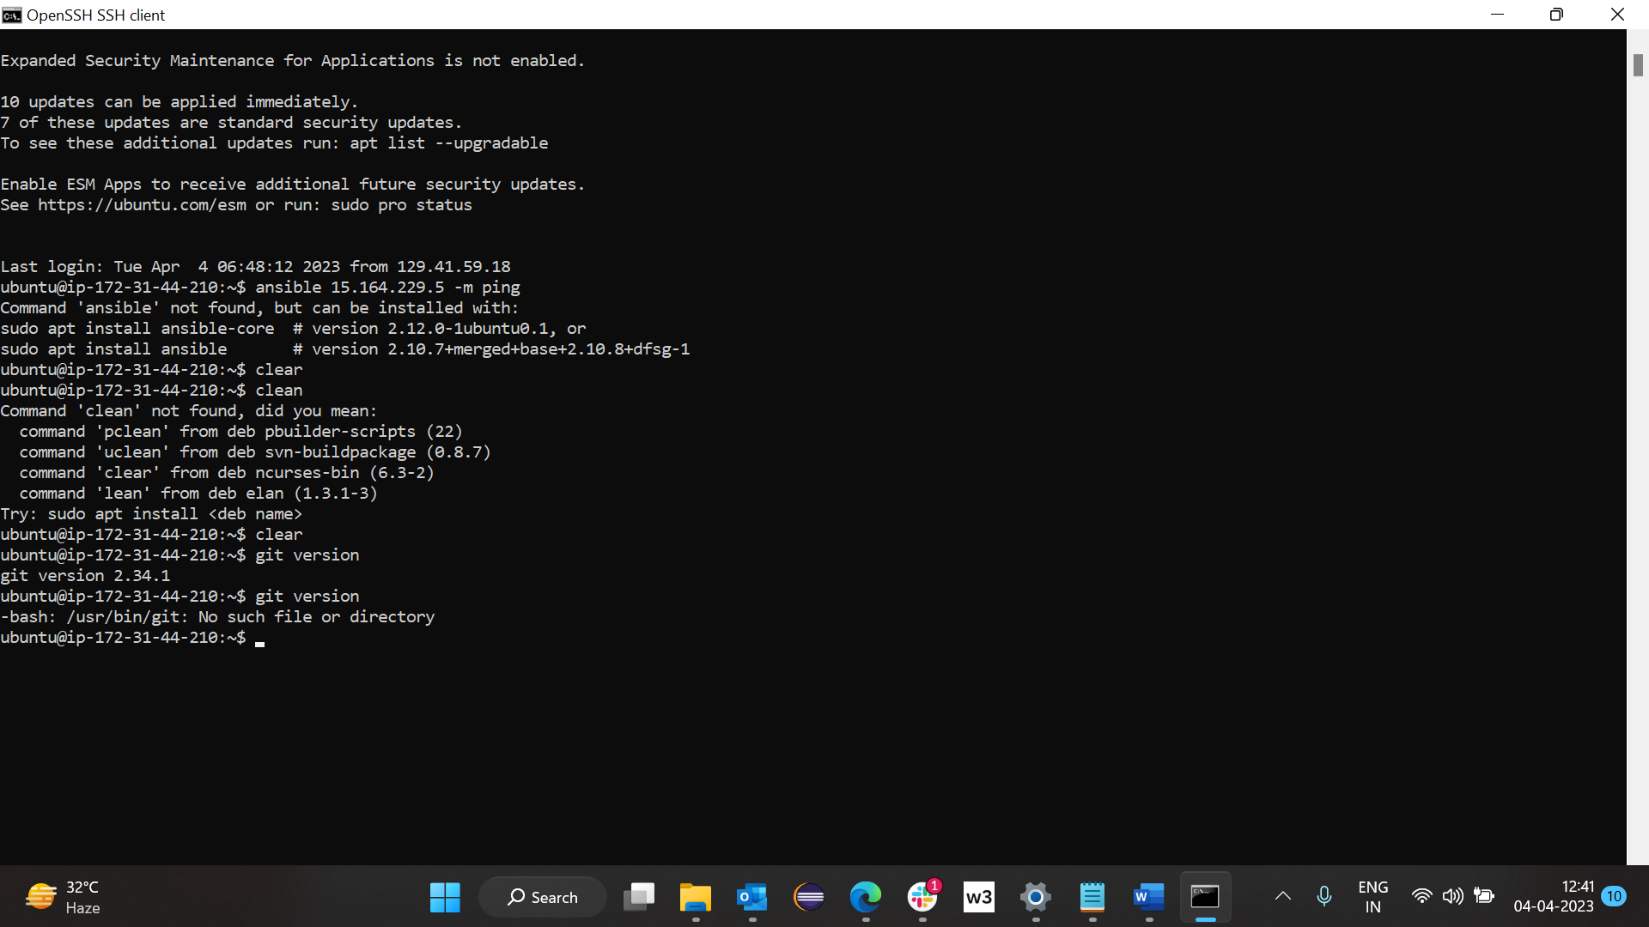

NOTE :

After removing git with above command, update command need to run on master(ansible all -b -a "apt update") and then again if you want to install git on nodes type (ansible all -b -a "apt inatall git -y")

Now we will check on node 1 : earlier it was showing no such file or directory but after installing git it shows git version 2.34.1 on node 1

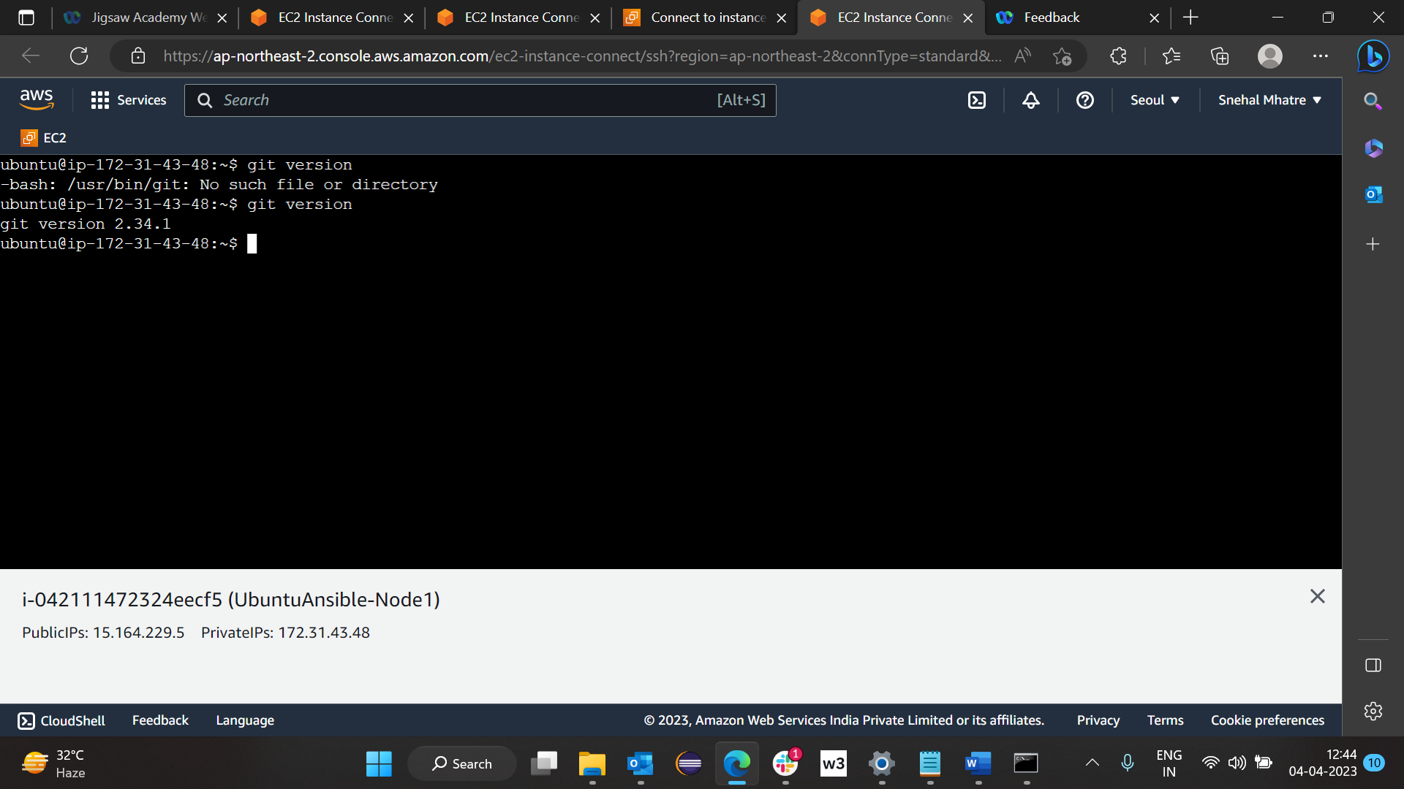

Now we will check for node 2 :

Same here for node 2 also.

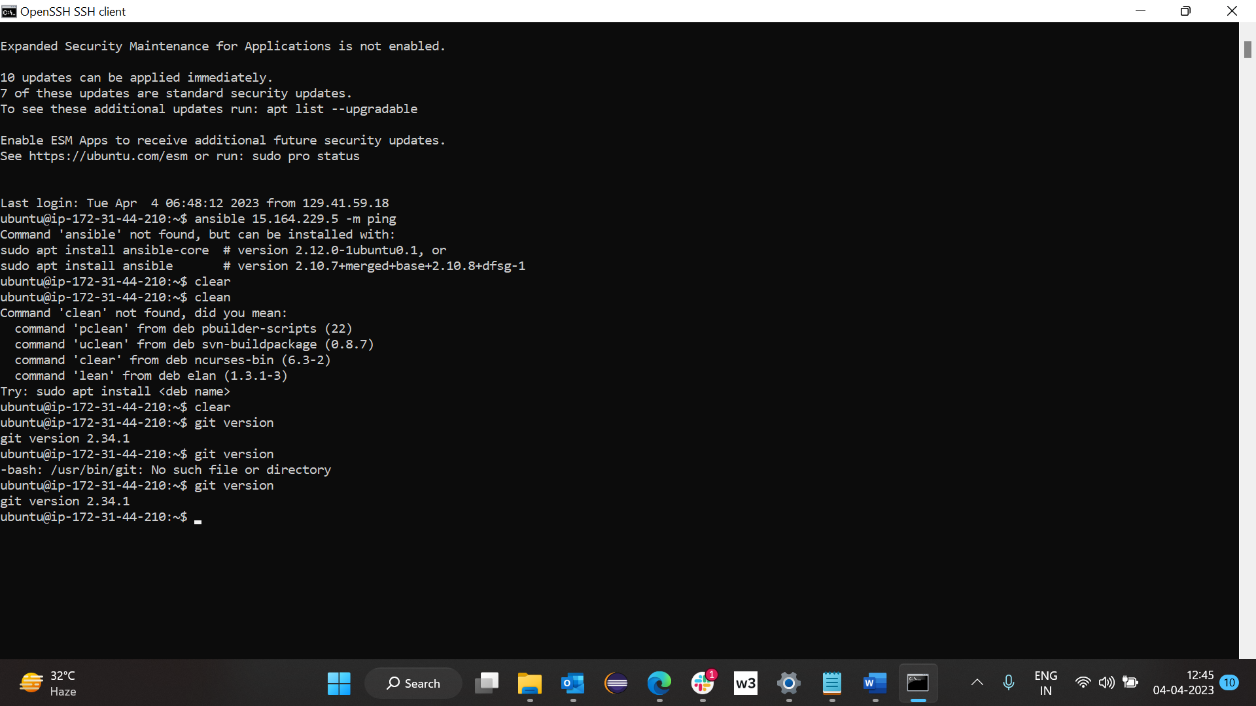

**Node Set UP:**

**Now On Node 1:**

Launch node 1 :

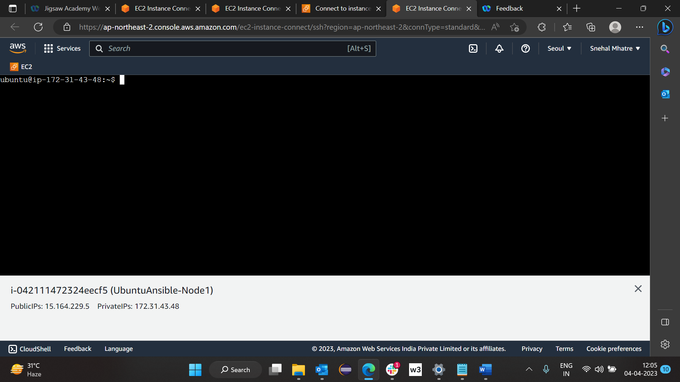

Go to .ssh folder here >> cd .ssh

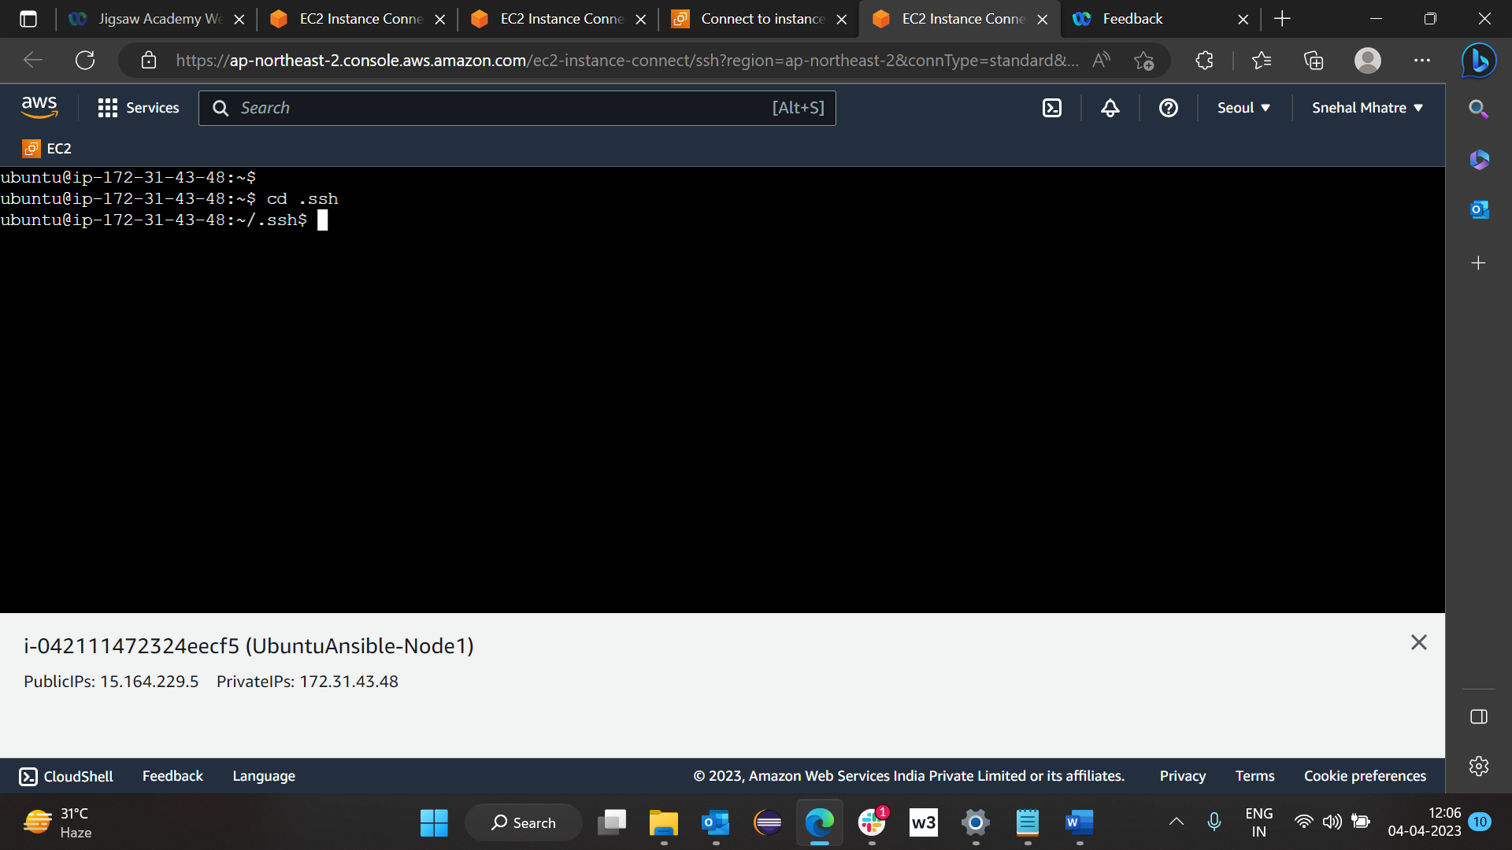

Type on node 1 : >> ls

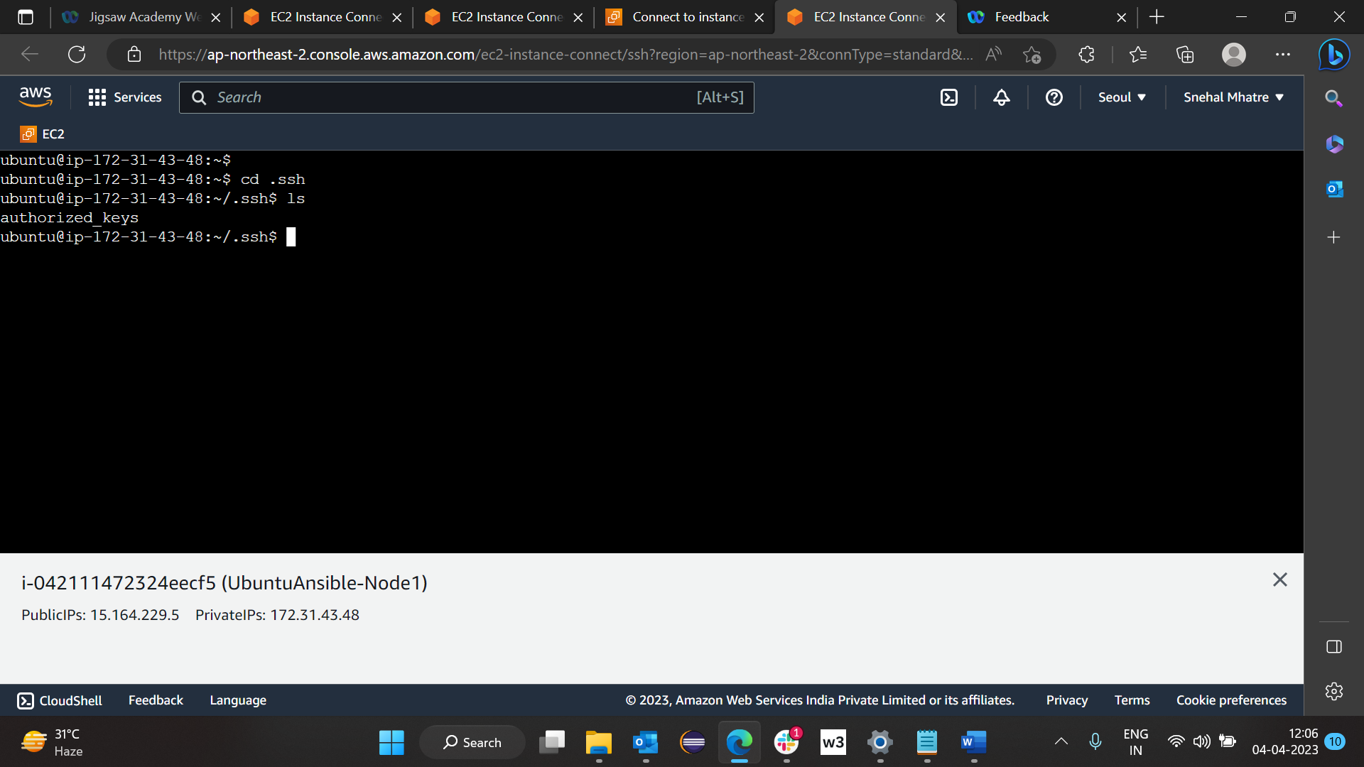

Here I have already added rsa key from host which is copied from host to add key in node type >> vi authorized_keys and press insert and go to end and press enter and paste key then press esc and :wq!

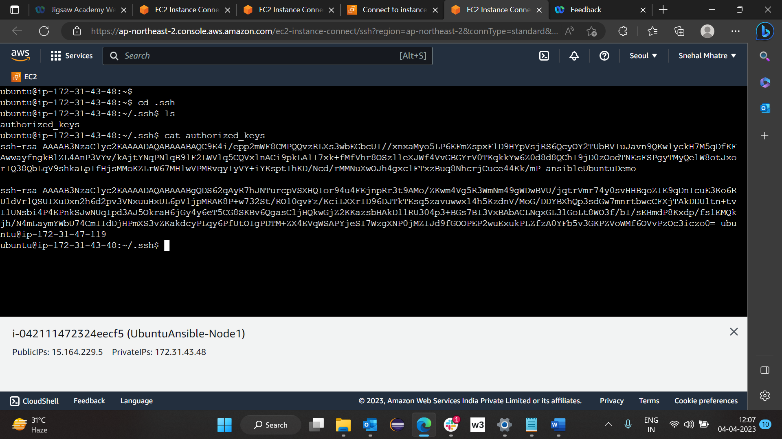

Above steps with node 2 which will open in command prompt

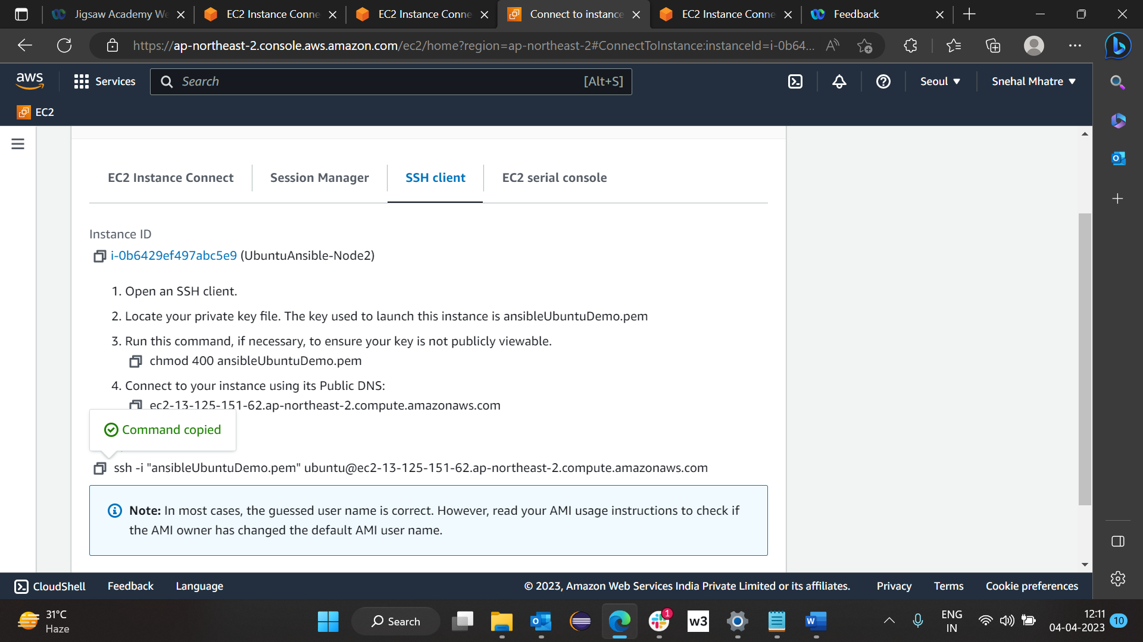

Open command prompt and go to download folder (folder where you keep key while creating machine)

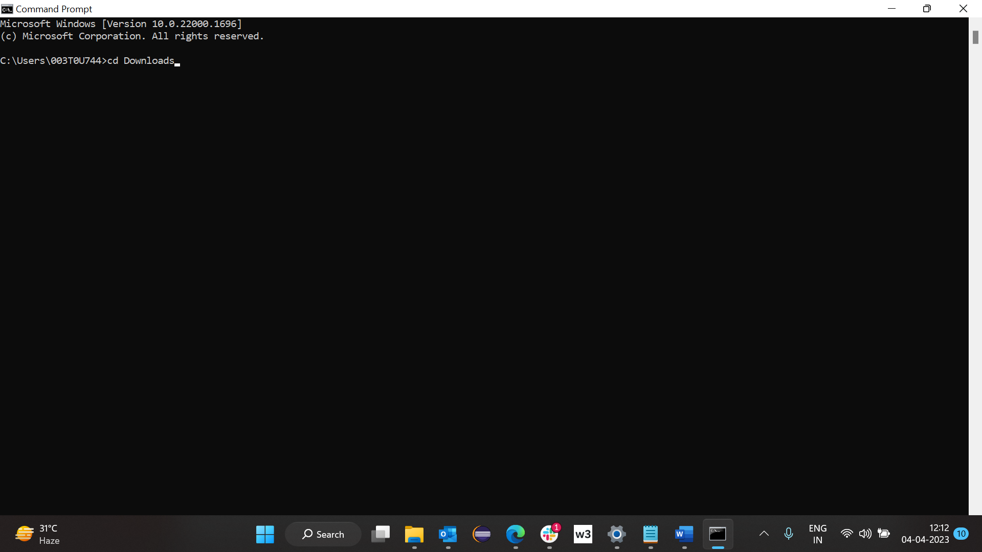

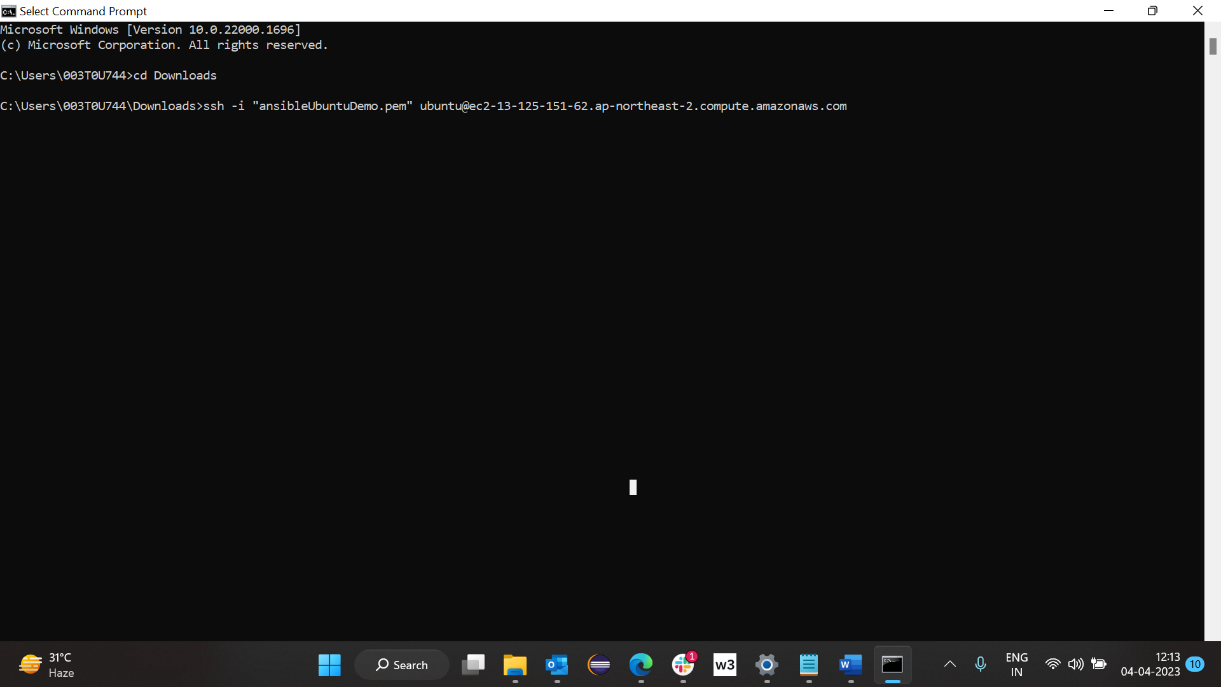

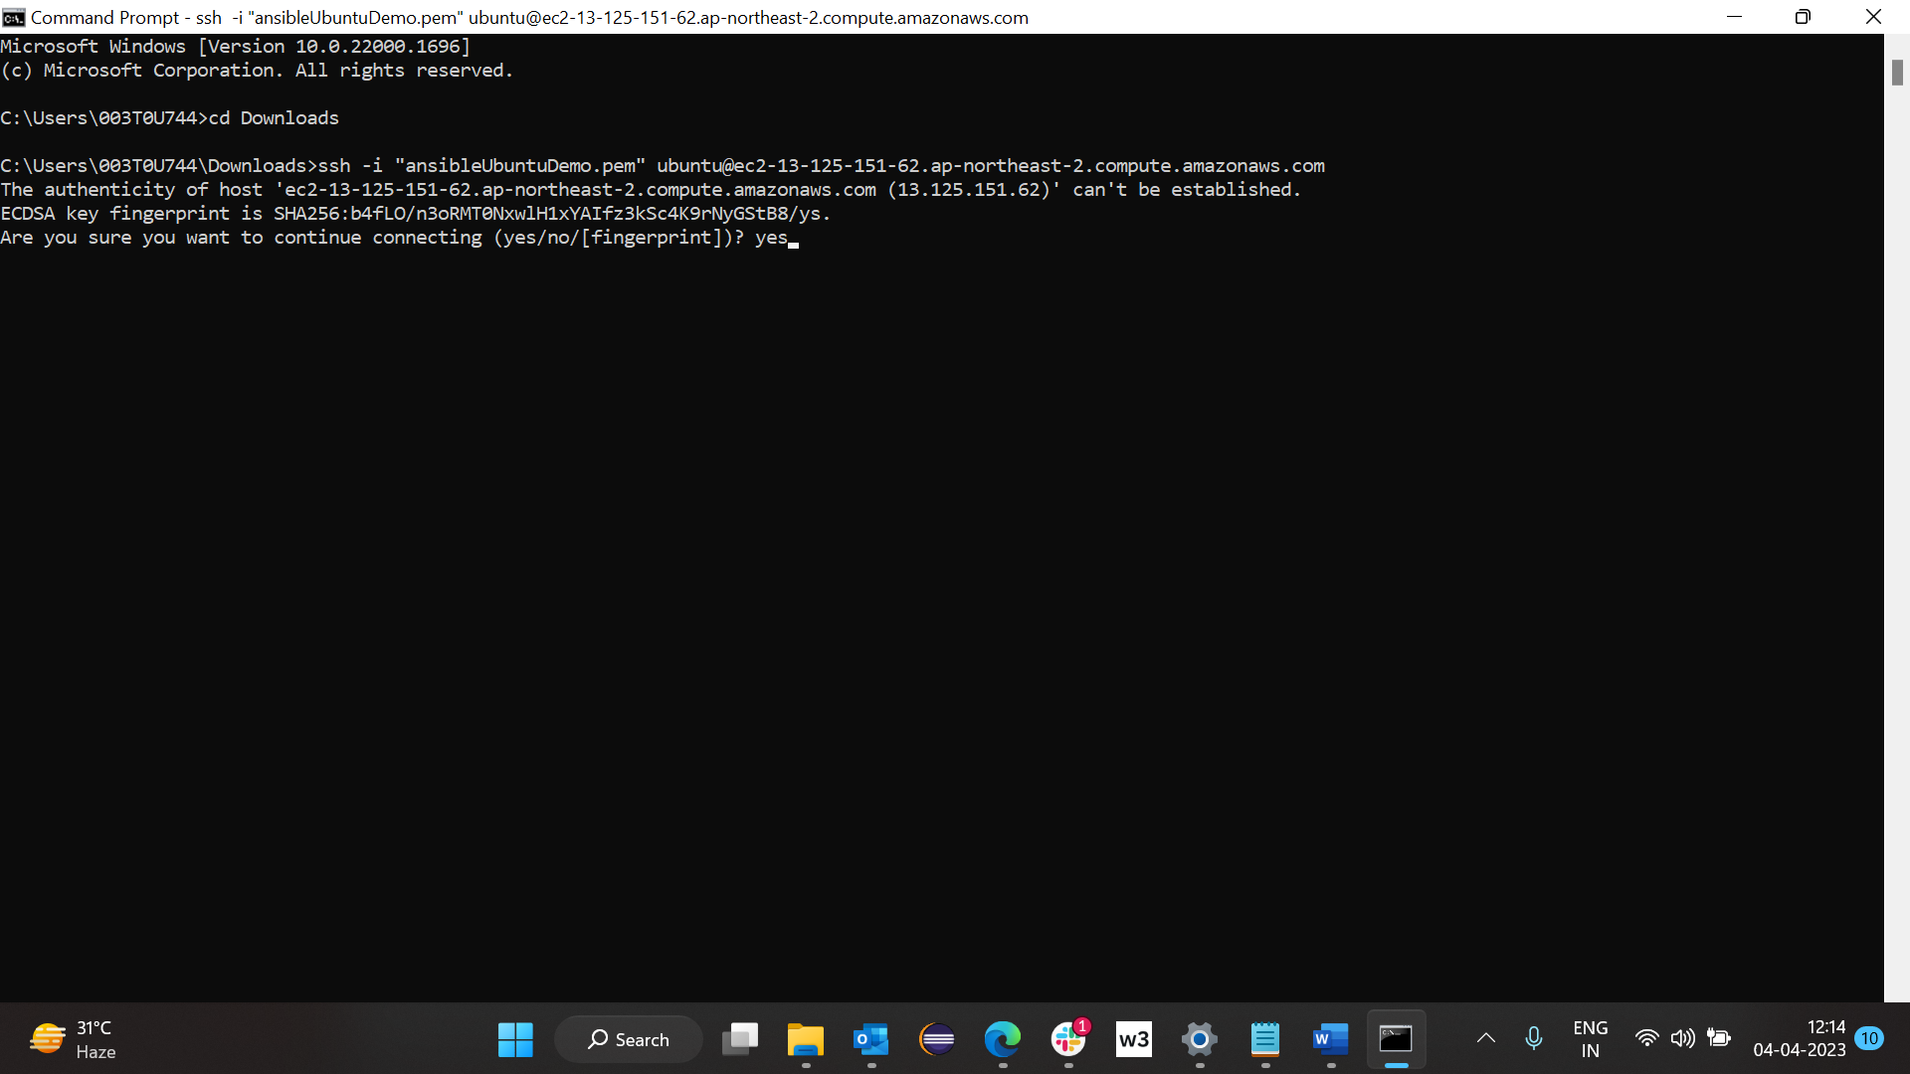

Now we are on node2

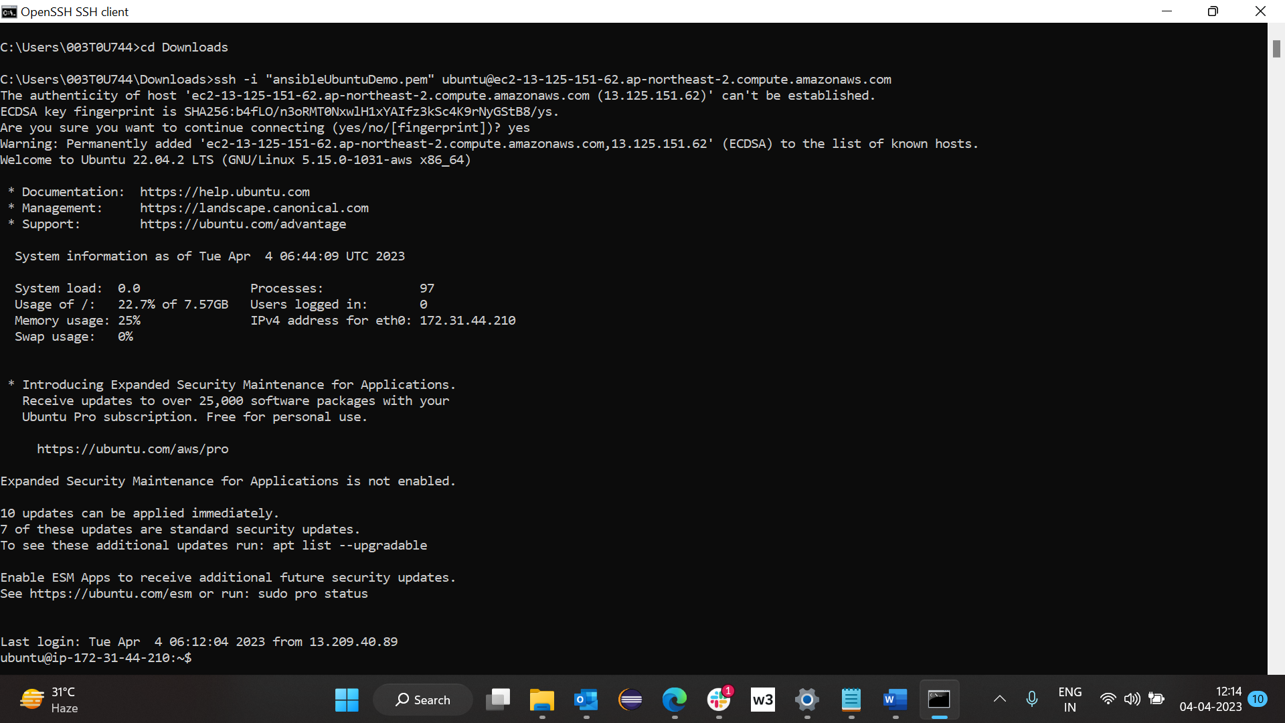

Do the same steps which are done for node1

Command Run on Master :

1. sudo apt update
2. sudo apt install software-properties-common
3. sudo add-apt-repository --yes --update ppa:ansible/ansible
4. sudo apt install ansible
5. ansible –version
6. ls -a
7. cd .ssh
8. ls
9. ssh-keygen
10. ls
11. cat id_rsa.pub

Then open Node :

1. cd .ssh
2. ls
3. cat authorized_keys
4. vi authorized_keys
5. Paste from id_rsa.pub of master to here and esc and :wq!

Come back to master again:

1. Cd ../../..
2. Cd etc/ansible
3. sudo chmod 777 hosts
4. vi hosts
5. Now at end of hosts file paste all ip address of nodes as per below format

[ipaddressIBM]

Ip address of node1

Ip address of node2

So on and then press esc and :wq!

1. ansible ip address node1 -m ping
2. ansible ip address node2 -m ping
3. ansible all -m ping
4. ansible all -b -a "apt update"
5. If we want to install git check first git is present on node then type on master if git present >> ansible all -b -a “apt remove git -y”
6. Again press on master >> ansible all -b -a "apt update"
7. If git is not present then type >> ansible all -b -a “apt install git -y”

On Master apply ad hoc command:

Command executed : ansible all -m apt -b -a "name=git"

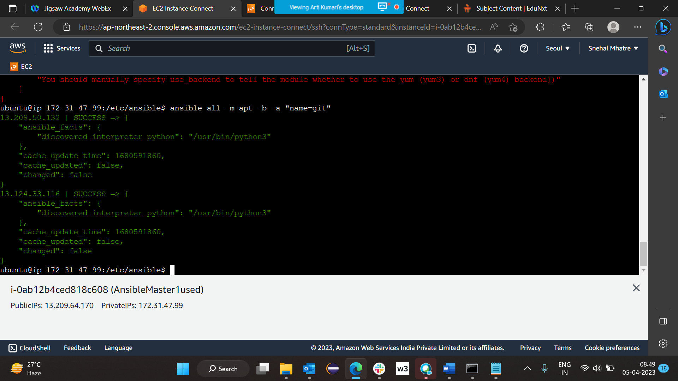

Command executed : ansible all -m apt -b -a "name=git state=present"

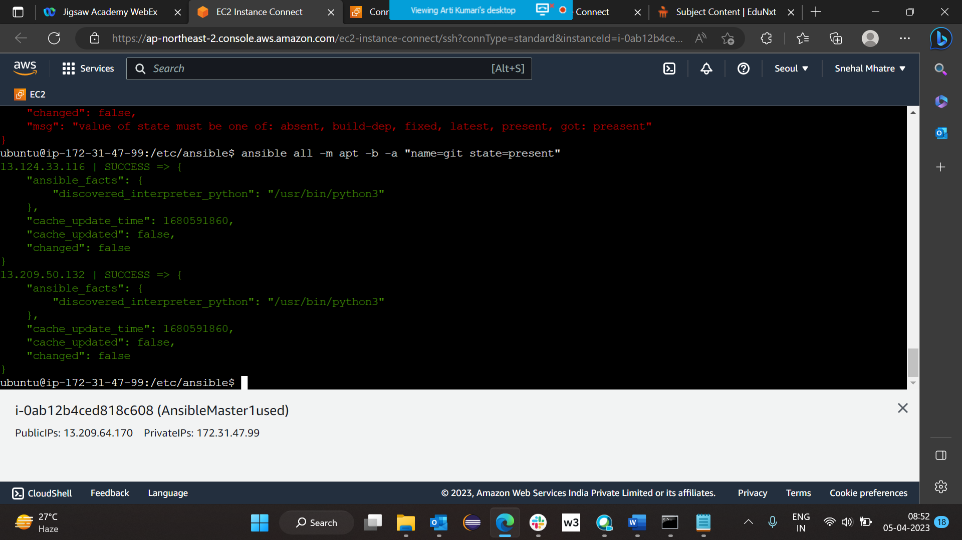

Command used : ansible all -a "apt install git -y" -b

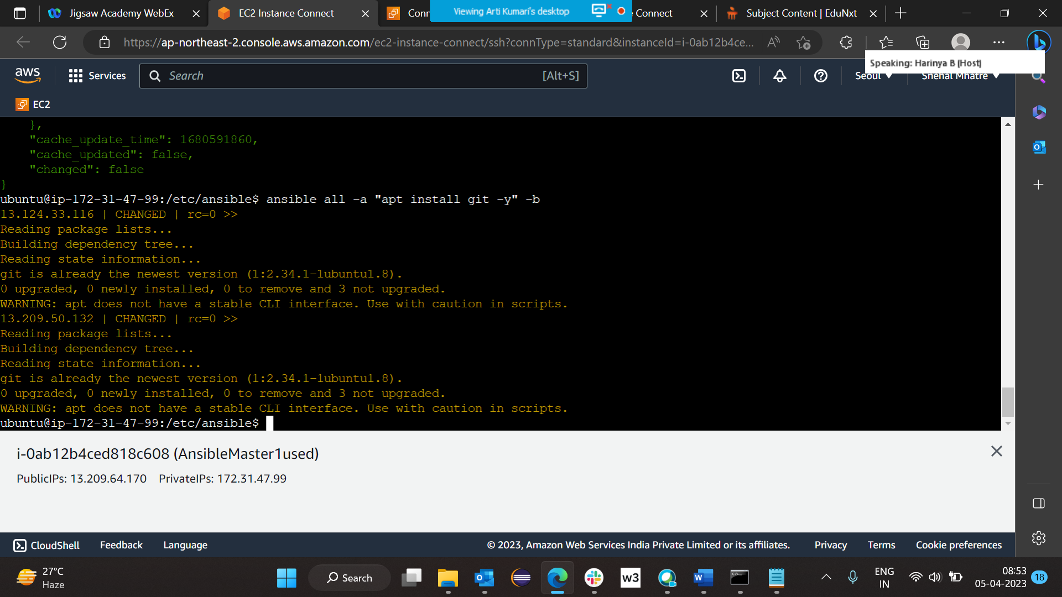

Command used : ansible all -b -a "apt install git -y"

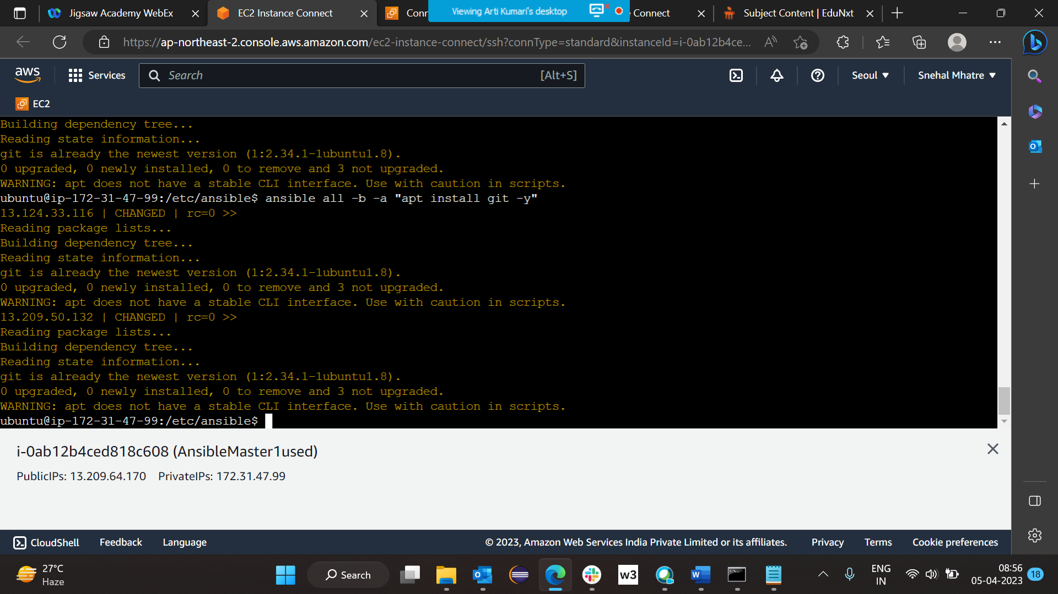

Command Used: ansible all -m apt -b -a "name=git state=present"

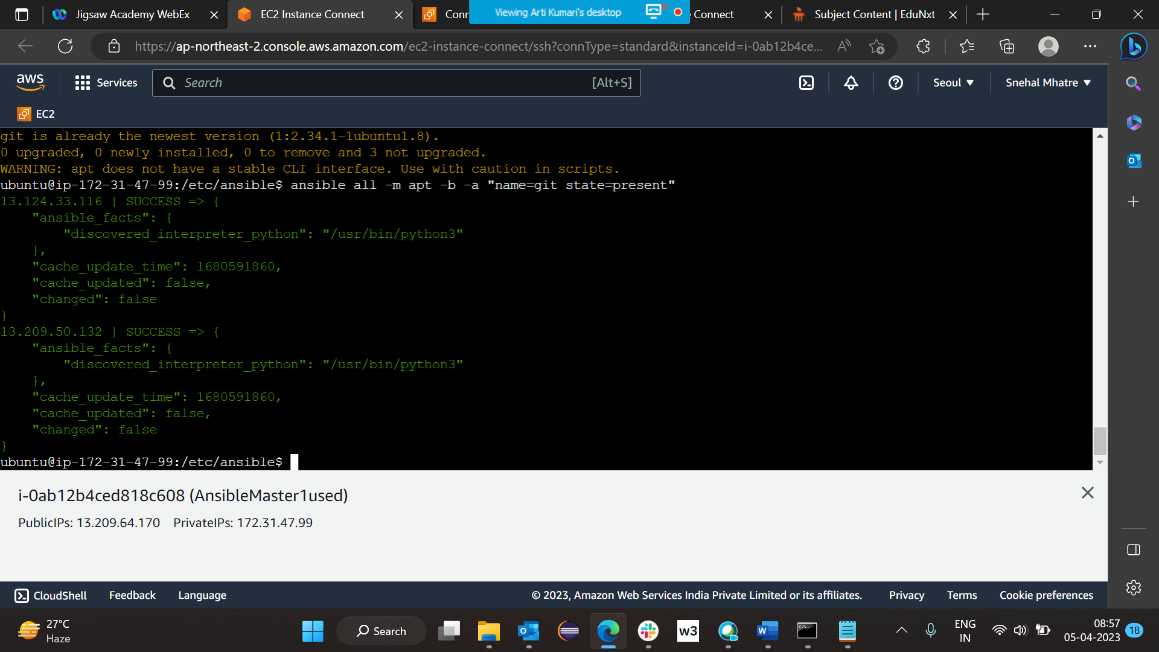

Command Used : ansible all -m apt -b -a "name=git state=absent"

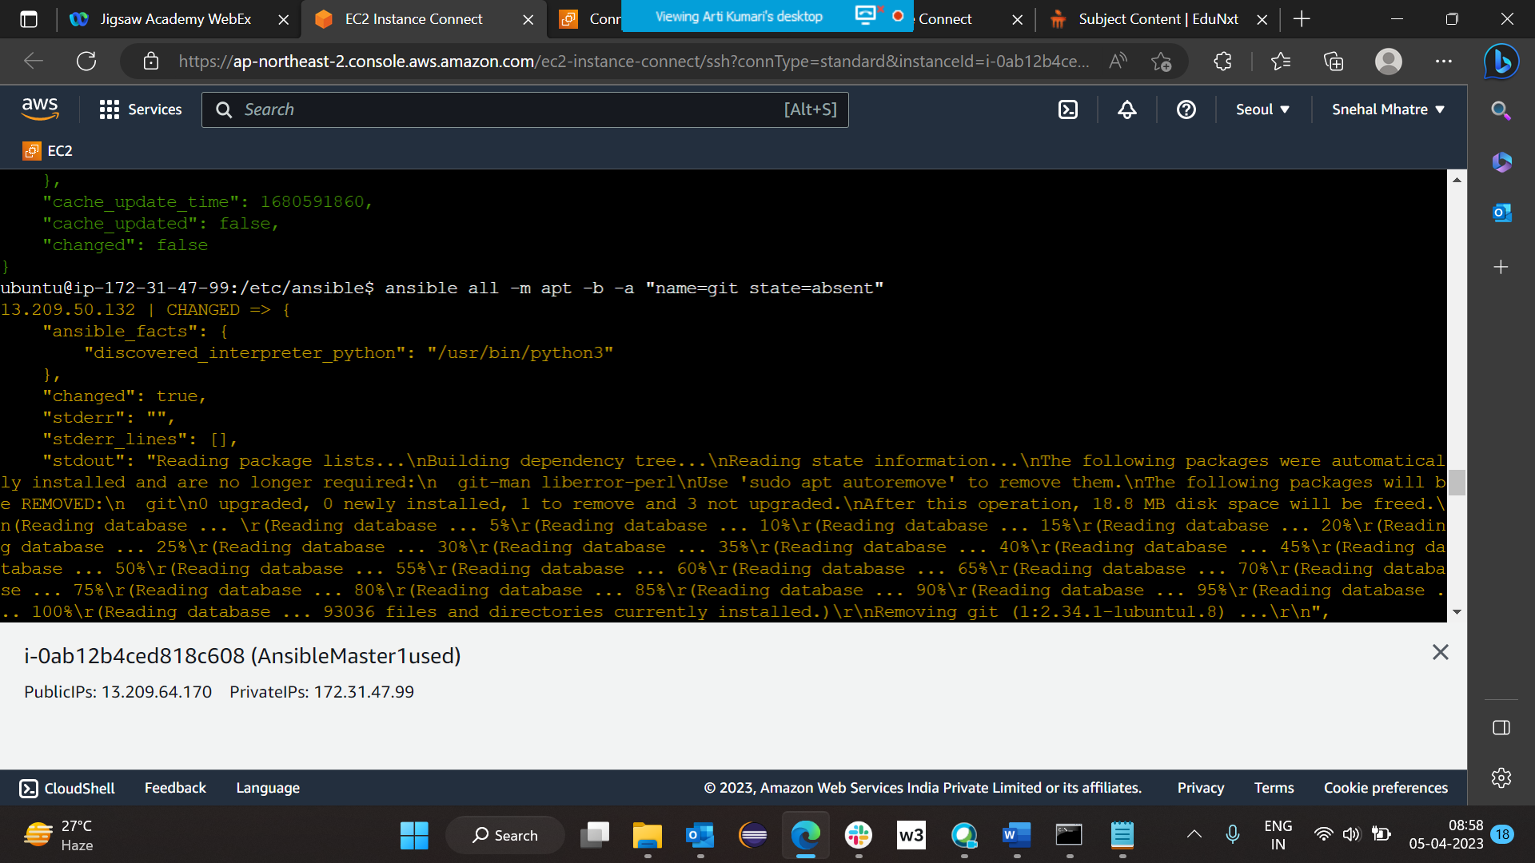

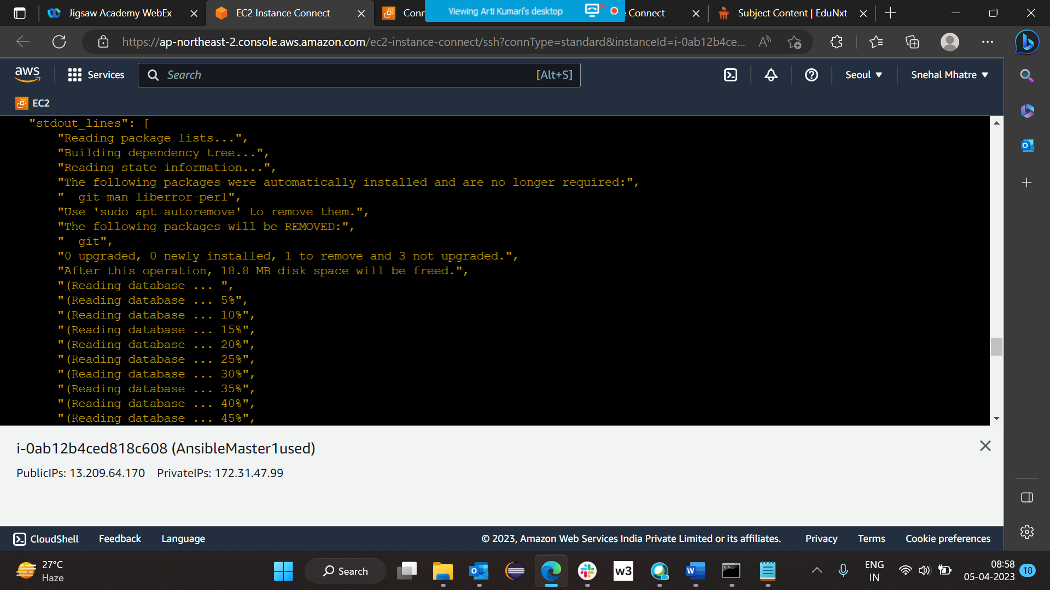

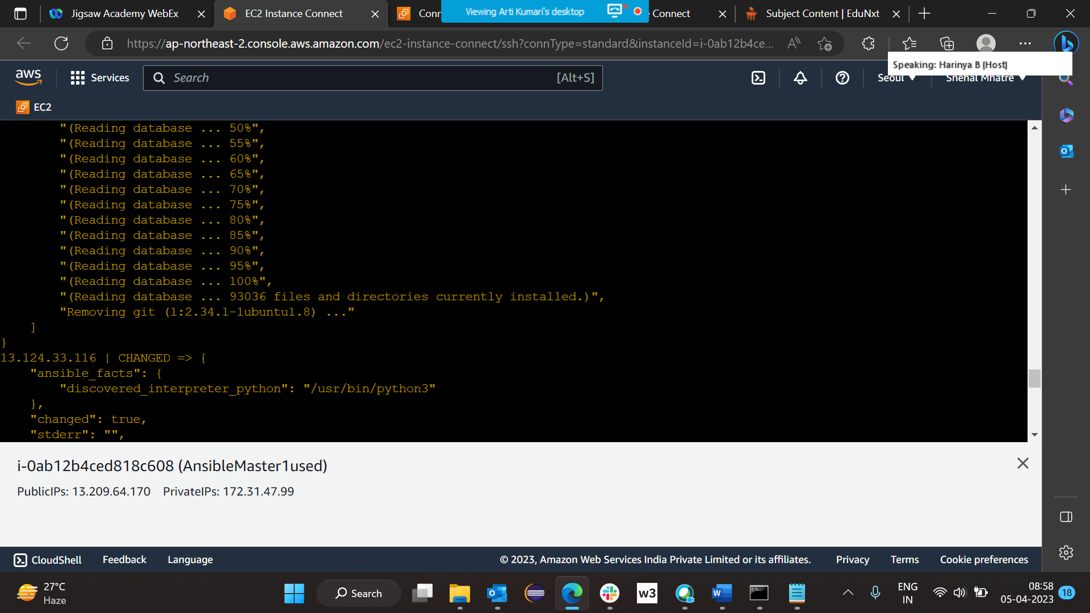

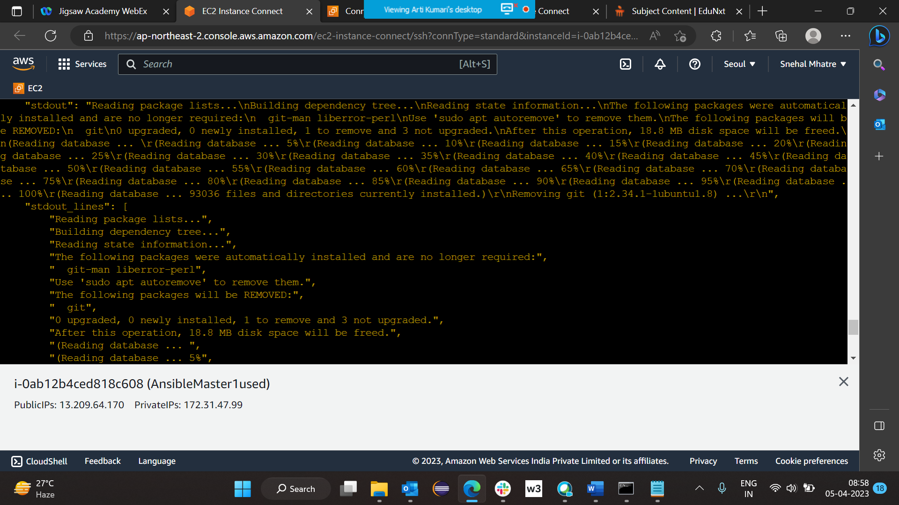

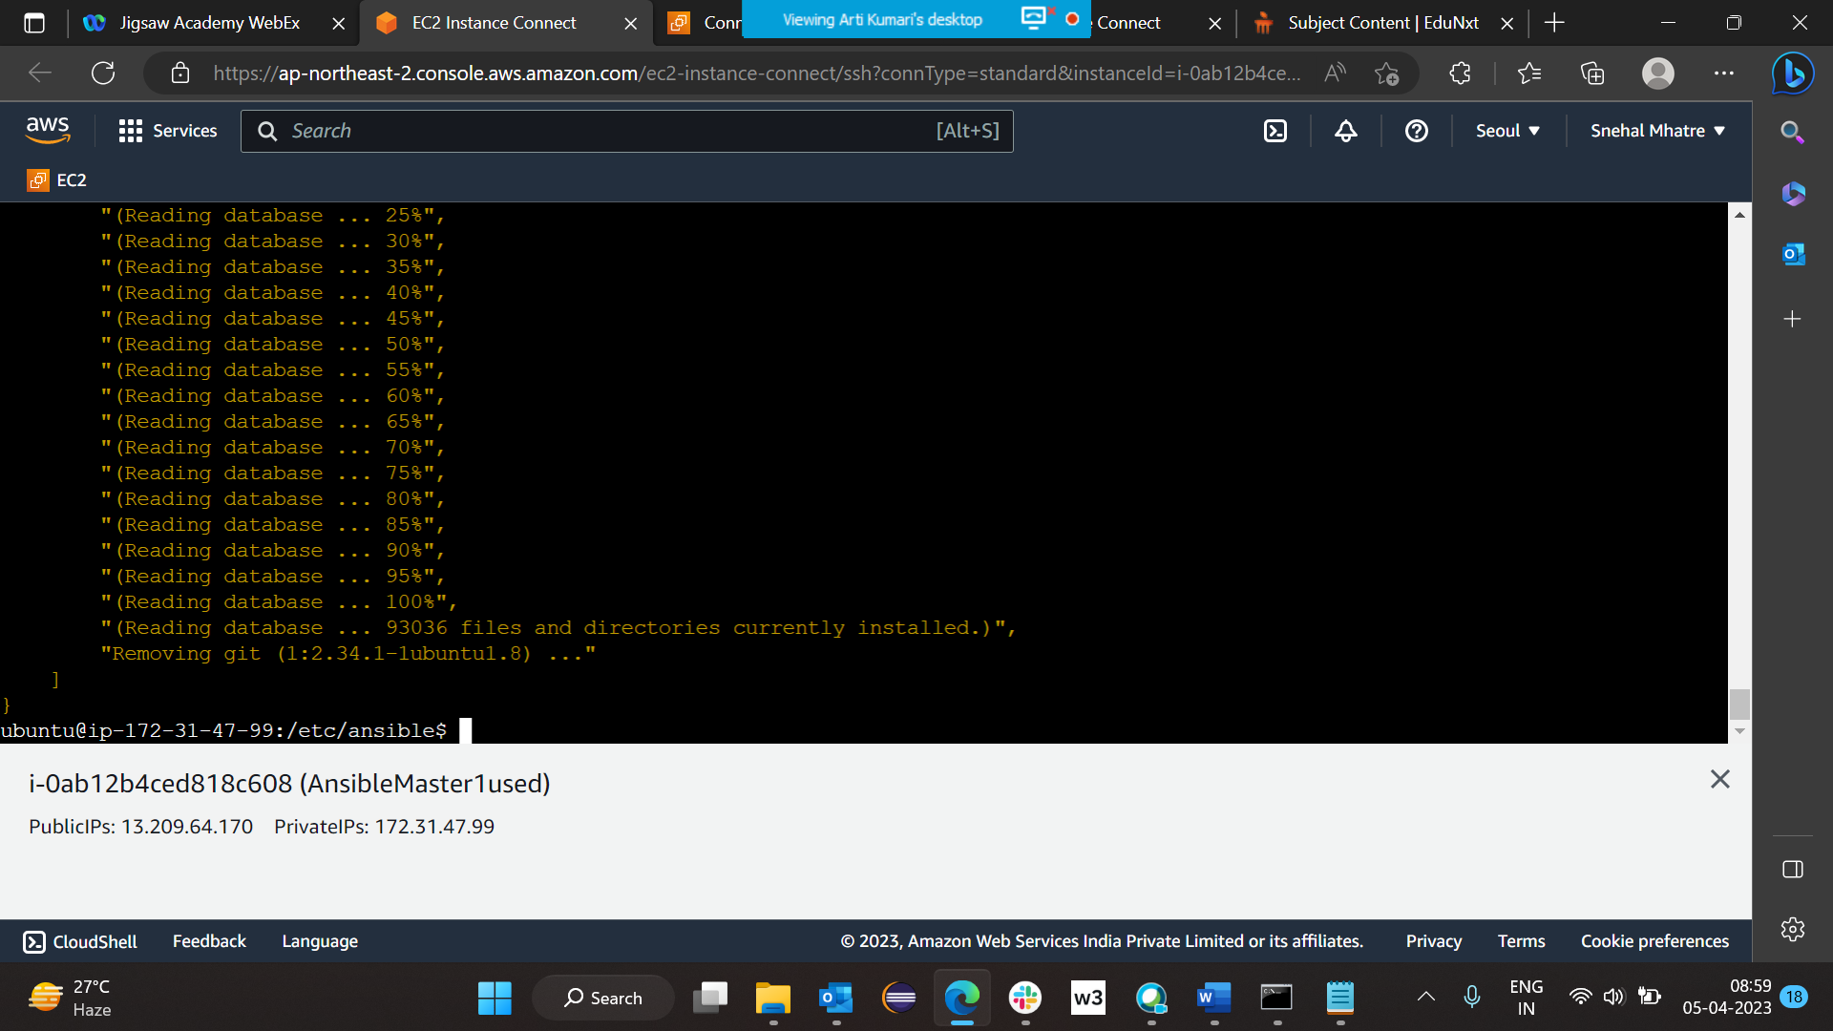

Command used : ansible all -b -a "apt remove git -y"

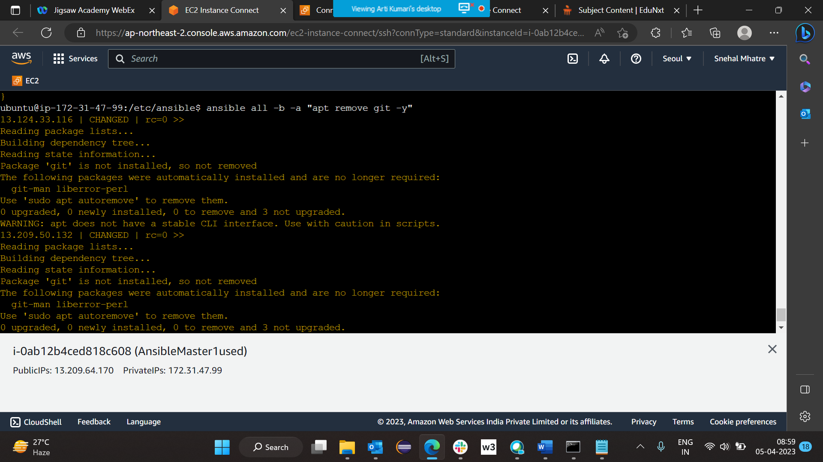

Command used: create file >> ansible all -b -a "touch /opt/abc"

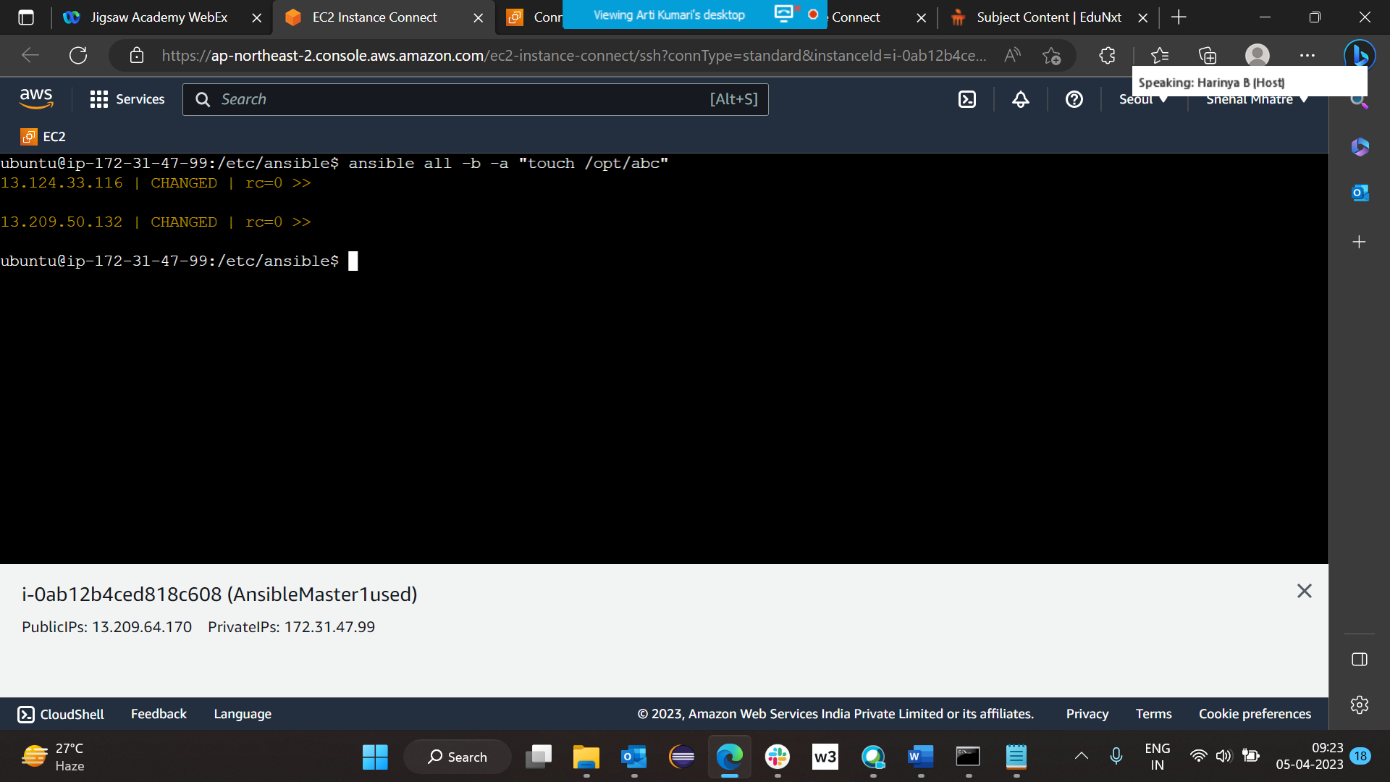

Making directory >> ansible all -b -a “mkdir /opt/TestingFolder”

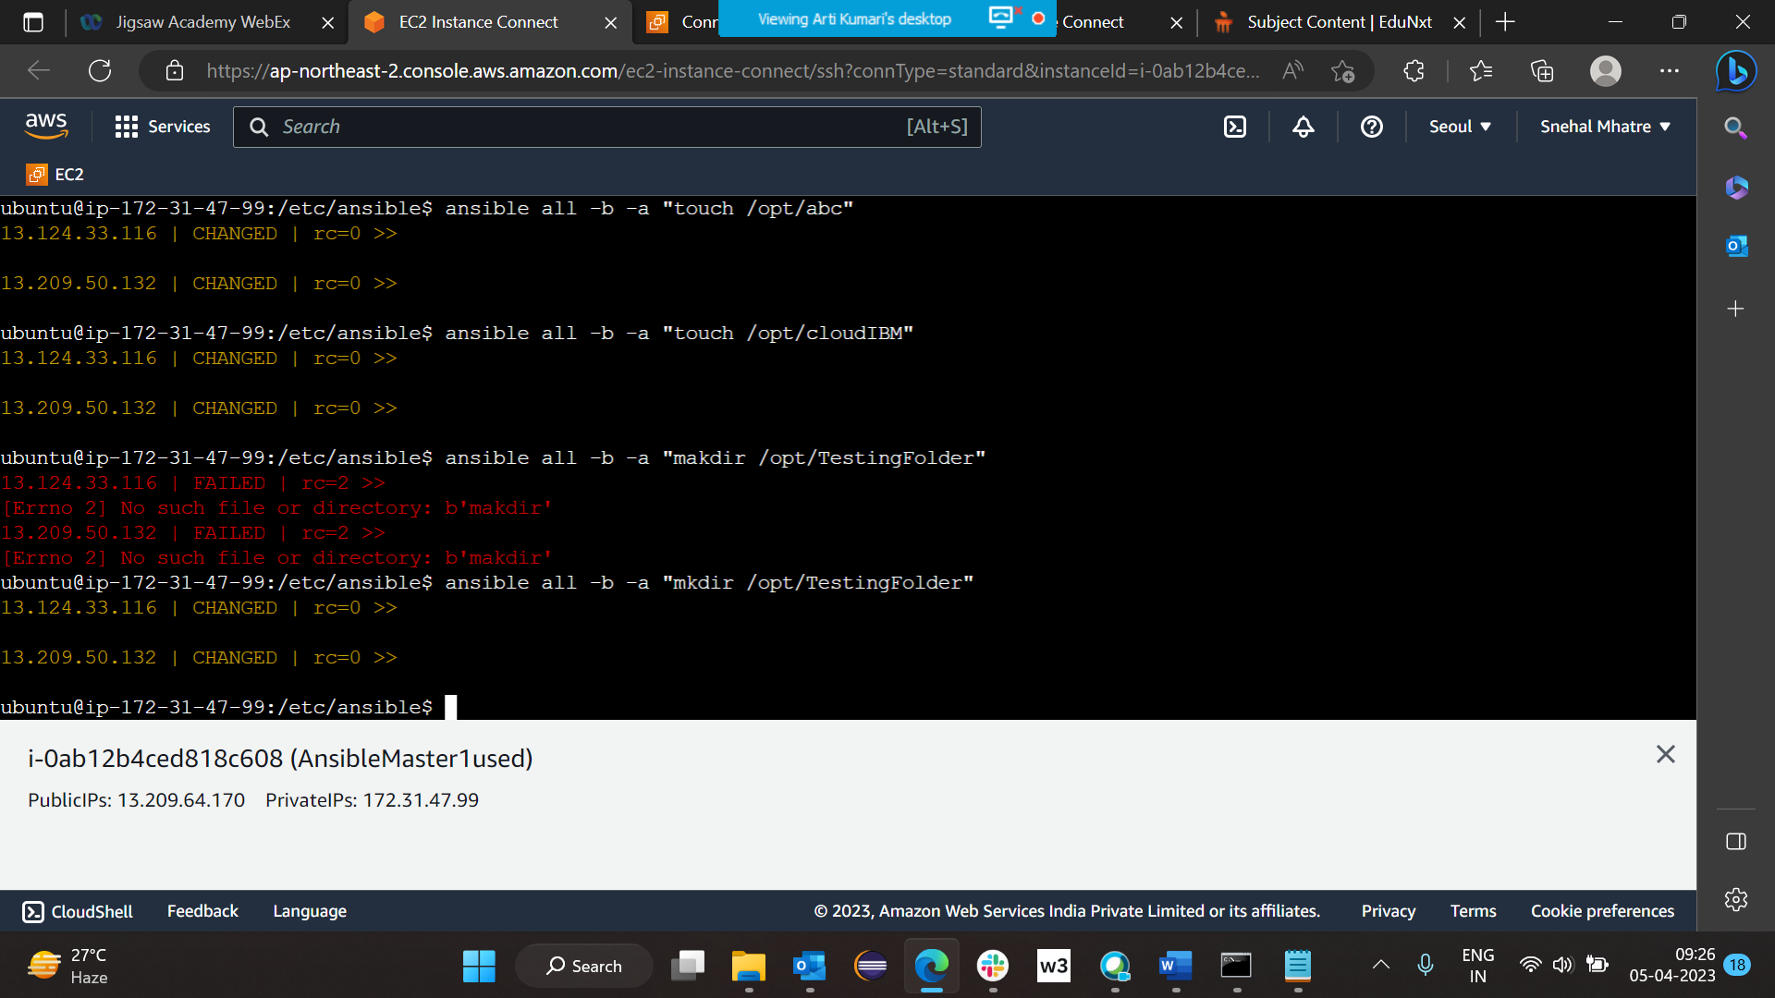

Creating File >> sudo touch filename

Give all permission >> sudo chmod 777 filename

Now edit file >> vi filename

Create file with .yaml extension

Eg> play1.yaml

Data present in play1.yaml >>

---- hosts: all become: yes tasks: - name: Installing git package apt: name=git state=latest

To run yaml file >> execute command >> ansible-playbook play1.yaml

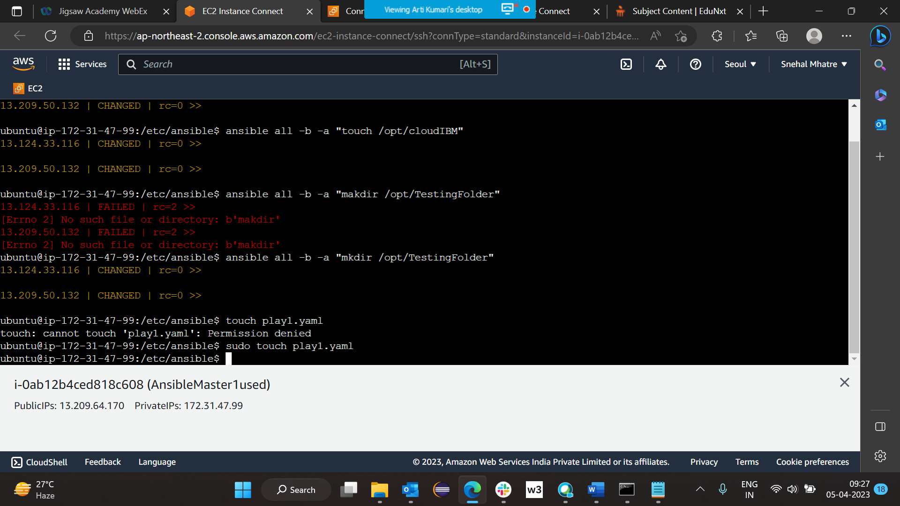

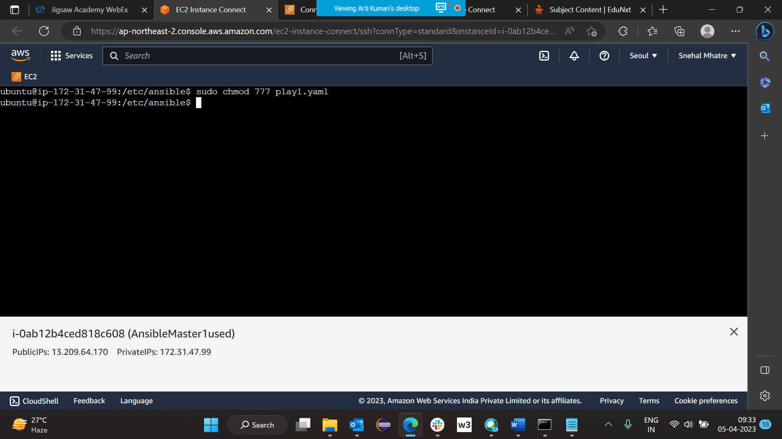

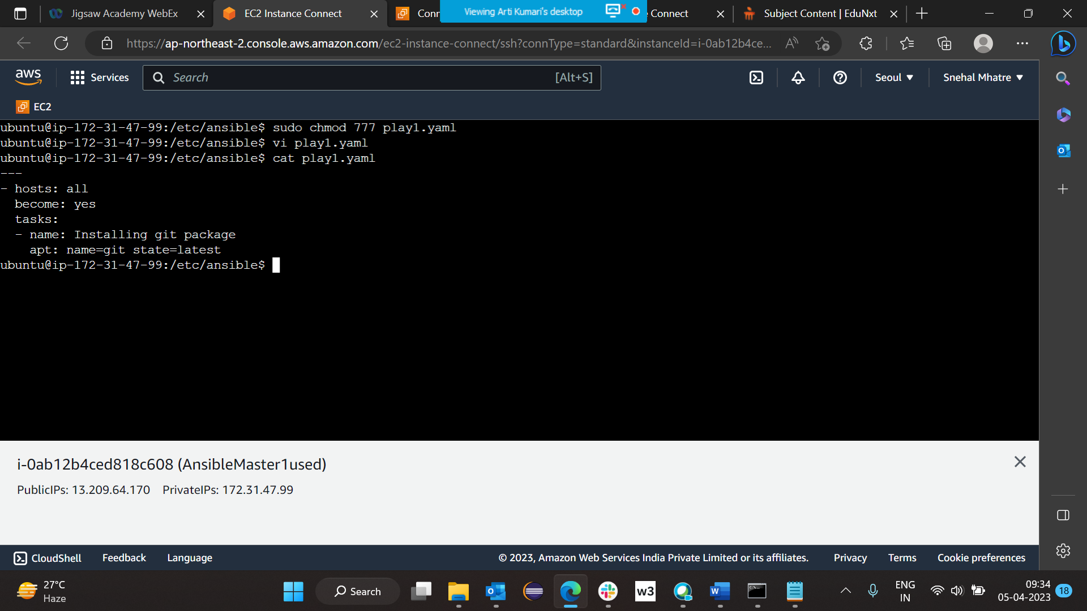

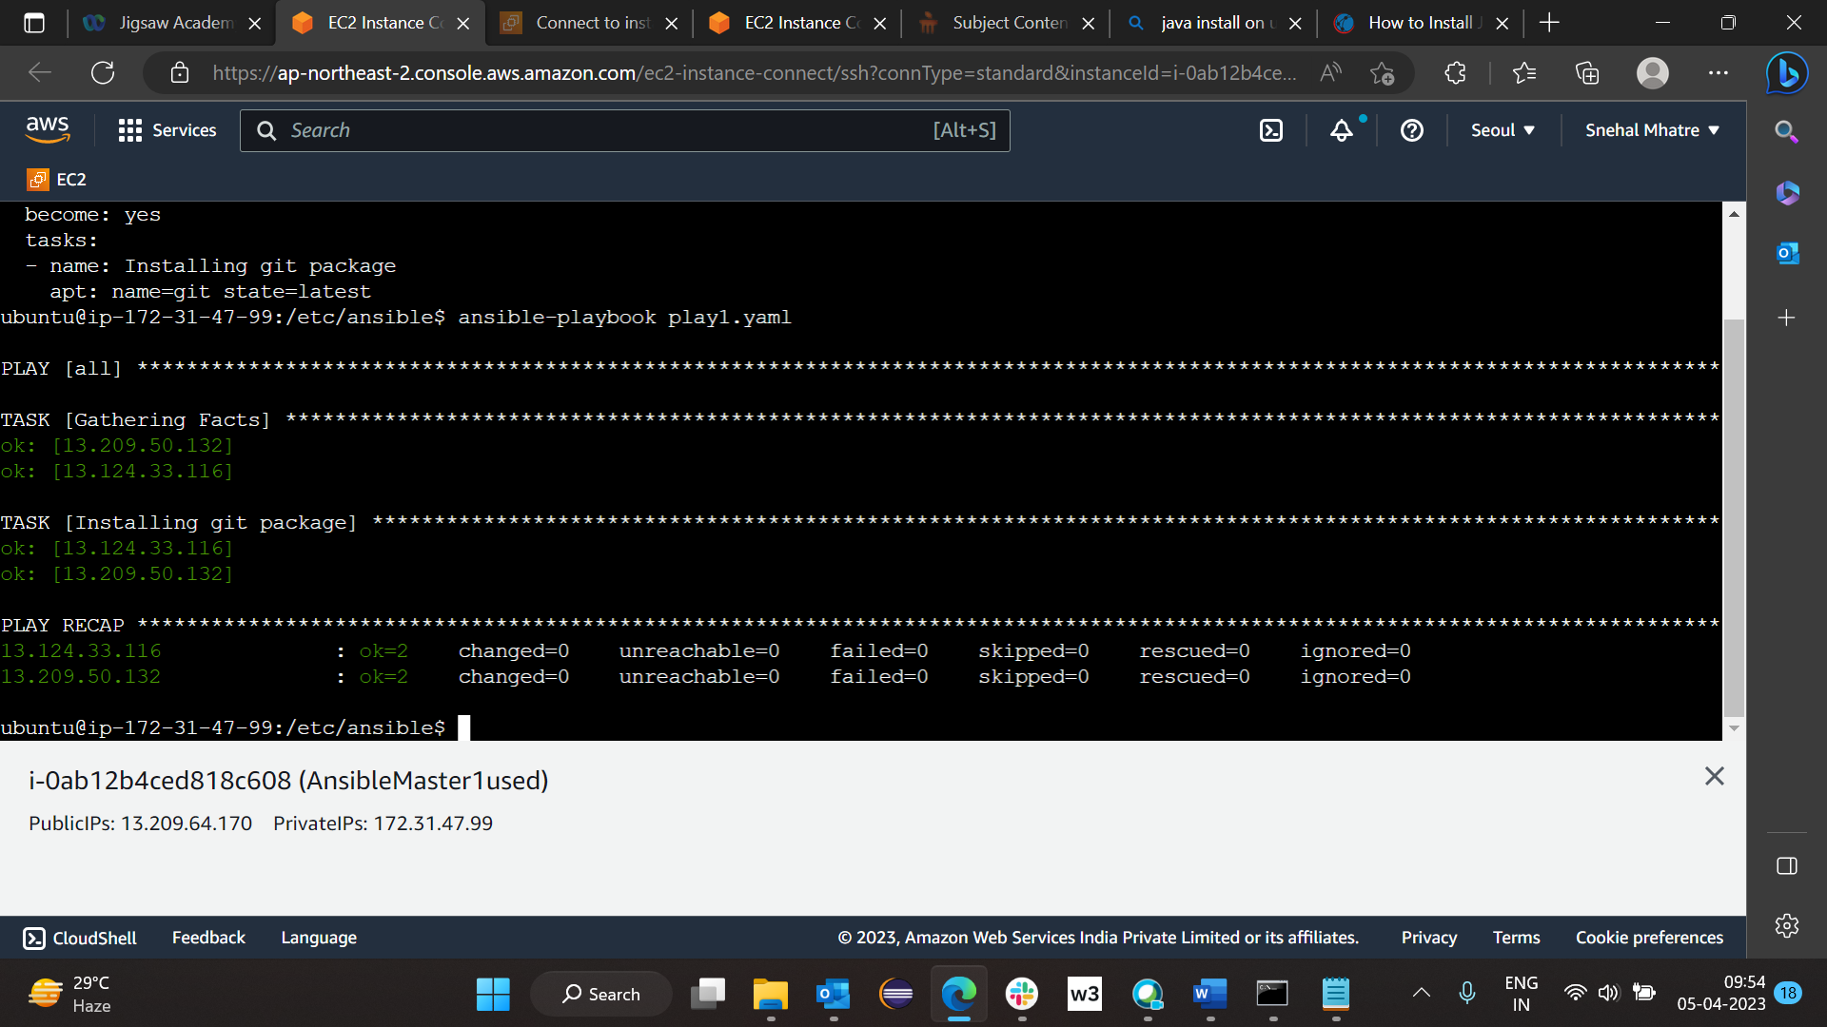

Installing multiple package at time

